

HoloDesk VR
Interim Report

TU856
BSc in Computer Science

James Lawlor
C22388703

Damian Bourke

School of Computer Science
Technological University, Dublin

14/11/2025

Abstract

This project is focused on designing and implementing a VR application which will act as a tool to increase focus and productivity for both work and study, by immersing the user in a distraction-free virtual environment, as well as by simulating additional computer monitors.

Students in today’s world face issues like the inability to focus, being easily distracted by devices, and needing to do some of their most intense work in the same place that they sleep and relax. This project aims to address this concern by giving them a separate, distraction-free, virtual workspace. This app will also enable users to work as though they have a multi-monitor computer setup, maximising their screen real estate.

Declaration

I hereby declare that the work described in this dissertation is, except where otherwise stated, entirely my own work and has not been submitted as an exercise for a degree at this or any other university.

Signed:

_________________________
James Lawlor

18/11/2025

Acknowledgements

I’m very grateful to my supervisor, Damian Bourke, whose advice and assistance so far on the project have been invaluable.
I’m also grateful to the family and friends who have provided useful feedback and assistance throughout my work so far.
I will undoubtedly have more thanks to give for the final report come March.

Contents
1. Introduction 1
1.1 Project Background 1
1.2 Project Description 1
1.3 Project Aims and Objectives 2
1.4 Project Scope 2
1.5 Thesis Roadmap 3
2. Literature Review 4
2.1 Introduction 4
2.2 Alternative Existing Solutions 4
2.3 Technologies Researched 6
2.4 Other Research 7
2.5 Existing Final Year Projects 8
2.6 Conclusions 10
3. System Analysis 11
3.1 System Overview 11
3.2 Requirements Gathering 11
3.3 Requirements Analysis 12
3.4 Initial System Specification 18
3.5 Conclusions 19
4. System Design 20
4.1 Introduction 20
4.2 Software Methodology 20
4.3 Overview of System 20
4.4 Design System 22
4.5 Conclusions 32
5. Testing and Evaluation 33
5.1 Introduction 33
5.2 Plan for Testing 33
5.3 Plan for Evaluation 40
5.4 Conclusions 43
6. System Prototype 44
6.1 Introduction 44
6.2 Prototype Development 44
6.3 Results 50
6.4 Evaluation 50
6.5 Conclusions 51
7. Issues and Future Work 52
7.1 Introduction 52
7.2 Issues and Risks 52
7.3 Plans and Future Work 52
7.3.1 Project Plan with GANTT Chart 53
References 54

1. Introduction

1.1 Project Background
Current life for many students is one of distraction. The state of modern technology is such that we are never far from a device, and many of us find these devices distracting, attention-grabbing, and altogether detrimental to focus and concentration.[1] It is all too easy for students to have their attention span eroded by short-form content like TikTok or Instagram, dampening their ability to stay focused on a single task for longer periods. Additionally, many students do some of their most intense work, whether study or assignment, in their bedroom, the place where they relax and sleep. This has been shown to have negative effects both on productivity, and on quality of sleep, due to their association between the space and work.[2]
The purpose of this application is to provide users, primarily students, with a distraction-free virtual environment that they can fully immerse themselves in, effectively giving them a separate space in which to work. Additionally, students will be isolated from their phone, which is often the biggest problem device in terms of distractions.

1.2 Project Description
Ideally, a user could be entirely isolated from all devices that could provide a distraction, but most of a student’s work in the modern day is digital, and is done on their laptop. To this end, the app will stream from the user’s computer screen to a virtual screen within the VR workspace, as well as being able to simulate additional screens, acting identically to physical monitors connected to the computer. It will also include additional features, such as interactive VR elements, such as buttons, switches, or levers, which can be used to trigger preset or customized macro-like shortcuts. Additionally, it will support full customization, both for the VR environment, and the positioning of the interactive elements. A user should be able to change their surroundings to whatever they like
The implementation of this project will be a VR application, built using a combination of C# and GDScript, in the Godot game engine. It will also use an Indirect Display Driver or virtual display driver to simulate the additional monitors. Because the application will run on the user’s PC or laptop and not locally on the VR headset, it should work with any VR headset.

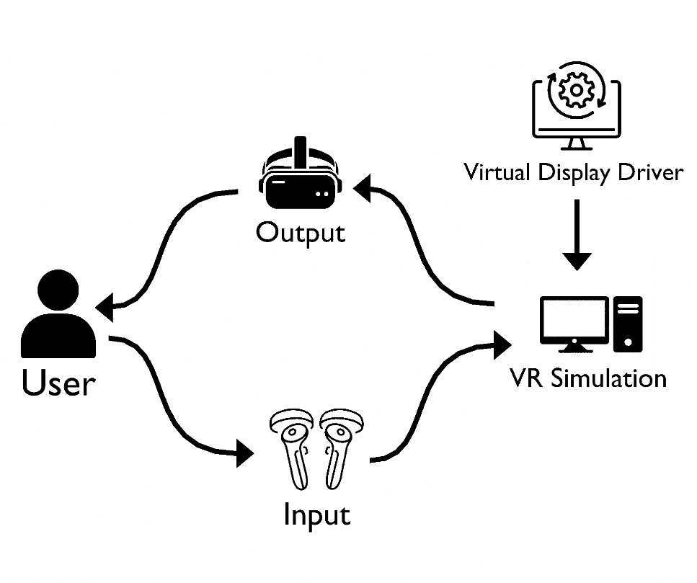
Figure 1 - A simplified system diagram

1.3 Project Aims and Objectives
The aim of the project is to is to provide an immersive virtual workspace that can help boost a user’s focus and productivity. In order to create an ordered and easily maintained application, I’ll need to develop the application with a clear methodology in mind. Since the Agile development methodology is generally used for teams of multiple developers, I’ll use an adapted version of it, intended for a single developer.
In order to achieve my main objective, there are several goals I must meet:
- Research existing solutions to the core problem.
- Research display driver technology and how to interact with it.
- Understand what will make a virtual environment immersive.
- Understand what makes a good VR user interface.
- Design and develop the application.
- Perform user testing and get feedback to improve on.

1.4 Project Scope
The main focus of this project is on the creation of an immersive virtual reality workspace, and on the inclusion of:
- Simulated virtual computer monitors that behave identically to real ones.
- Interactive VR elements that can be used to trigger macro-like shortcuts and commands.
It will be developed in the Godot game engine, and will be compatible with most major VR headsets. The user will receive visual and audio output via the headset, and will perform input, such as interacting with monitors, via the VR headset’s compatible controllers. The user will be able to customize almost anything about their workspace, including the surrounding environment, the layout and positioning of interactive elements, and the position and number of monitors. The virtual monitors will use a virtual display driver to simulate an additional monitor connected to the user’s computer, and the Godot game engine will capture the simulated contents of this extra screen, and cast it to the simulated environment.
This project will not be a VR game, but a study tool, and as such will not feature many of the elements commonly seen in a VR game, such as collectible items, non-player characters or enemies, or a scoring system.

1.5 Thesis Roadmap

Literature Review
- This chapter will explore other existing solutions to the problems that this project tries to solve, including what features make these alternatives more or less appealing. It will also review my own research on these problems, and how my project can solve them.

System Analysis
- This chapter will discuss the requirements gathering process and how I went about it, as well as what the results of that process were, and turning them into workable functional and non-functional requirements.

System Design
- This chapter will explore how the requirements identified in the previous chapter are translated into a structured design, using a modified Agile methodology. This will include system architecture and UML design models, as well as discussion on the technologies considered for use, and which ones were deemed appropriate.

Testing and Evaluation
- This section will look at what the test process will be like for the system, including plans for the different forms of testing that will be used, and a plan for achieving full test coverage of the system.

System Prototype
- This segment will discuss my development of the system prototype, which will include functionality at the most basic level of all key systems.

Issues and Future Work
- This chapter will look at risks associated with the project as I continue to work on it, as well as my plans for continued development going forward.

2. Literature Review

2.1 Introduction
This chapter will present the research and investigation performed on the problem at hand, and existing solutions to it. This includes an examination of similar applications to the one proposed for this project, as well as how the proposed project matches up to them. Additionally, this chapter will discuss research done on technologies and systems that could be used as part of the proposed system, and research done into the problem that the system aims to solve.

2.2 Alternative Existing Solutions
This segment will specifically explore the alternative existing solutions to the problem at hand, i.e. similar applications and systems to the proposed project. There are a number of them out there, but the most similar are Virtual Desktop, Immersed, and AirLink.

2.2.1 Virtual Desktop
Virtual Desktop is a VR desktop streaming application that comes in two versions: Standalone, and Classic. The standalone version of the application is intended for VR headsets that can run applications natively on the device (in which case you’d still need a computer to be streaming from), and the classic version runs on the user’s computer. It has the ability to simulate additional monitors. Only the classic version has support for custom environments, and only if the user creates these environments themselves.

2.2.2 Immersed
Immersed is a similar application to Virtual Desktop, in that it is primarily a VR desktop streaming application. It offers the same ability to use multiple monitors, and to change environments. It also has several features focused on collaborative work. These include the ability to bring collaborators into your virtual workspace, and for them to be able to see your virtual monitors. It also supports a collaborative virtual whiteboard. However, for most of its features the “full experience” is locked behind a monthly subscription.

2.2.3 AirLink
AirLink is the built in desktop streaming software on Meta Quest headsets. It is the simplest of the applications I looked at, in that it only really offers the basic functionality: streaming your computer screen into VR. It offers support for multiple monitors, but unlike the other apps, these are not virtual monitors. It can only stream real physical monitors connected to your computer. Aside from this, it doesn’t offer support for custom environments or any other special features, outside of using third-party apps or plugins.

2.2.3 Comparison
Below is a table representing a comparison of the three alternative solutions I reviewed, and the planned features for my own project.
 | Virtual Monitors | Max Number of Monitors | Custom Environments | VR Interactive Elements | Collaboration
HoloDesk | Yes | 5 | Yes | Yes | No
Virtual Desktop | Yes | 3 | Yes* | No | No
AirLink | Yes | 3 | No | No | No
Immersed | Yes | 3 | Yes* | No | Yes
Immersed (Subscription) | Yes | 5 | Yes | No | Yes

My aim for this project is to at least match most of the features of the other solutions, apart from collaboration, which is currently out of scope. With this view, the item with the most ambiguity is the maximum number of monitors. I have yet to ascertain the performance impact of having multiple monitors streaming at once, and this may be a limiting factor on how many a user can have at once.
However, simply the list of features an app has is not the only thing that measures its quality. As such, I have also considered each of the three alternative apps through the lens of Nielsen’s 10 Usability Heuristics, and ranked them from 1 to 10.

Heuristic | Virtual Desktop | AirLink | Immersed
1. Visibility of System Status | 8 | 7 | 9
2. Match Between System and Real World | 8 | 4 | 8
3. User Control and Freedom | 7 | 7 | 7
4. Consistency and Standards | 8 | 7 | 8
5. Error Prevention | 6 | 5 | 7
6. Recognition Rather than Recall | 6 | 6 | 6
7. Flexibility and Efficiency of Use | 6 | 4 | 7
8. Aesthetic and Minimalistic Design | 8 | 9 | 7
9. Help Recover from Errors | 3 | 3 | 7
10. Help and Documentation | 7 | 3 | 9

With these heuristics evaluated for each alternative solution, I now have something I can use for requirements, and to evaluate my own system against later on, and see how it compares.

2.3 Technologies Researched
Because this project is a VR application, I was severely limited in which technologies I could research. Being a VR app requires it to be developed in an engine with VR support. The two major options for this are the Unity and Godot game engines, which both have integrated VR support, as well as useful VR plugins and extensions. Within these game engines, there was also the choice of which programming language to use, as both engines support multiple languages. I’ve also done research into virtual display drivers, and whether it would be better to use an open source one from GitHub or to write my own, and whether it would be better to implement the project on Windows or Linux, considering I’ll need to do a lot of operating system-level interactions to integrate the display driver.

2.3.1 Game Engine
The two main items in consideration for game engine were Unity and Godot. Both offer good VR support, and extensions to add further support for VR interaction, movement, and general functionality. Unity offers a more complete experience and better community support, as it has been around for a lot longer. Godot, on the other hand, has the advantage of being open-source, and much more customisable. Neither engine seemed to be a clear winner based on features alone, but I ended up deciding to use Godot. This is primarily because I have worked on VR projects in Godot before, and so I have much more experience with that than with Unity. Additionally, Godot is the engine used by TUDublin’s XR Prototyping module, meaning I have better access to resources, and potentially the help of the lecturer.

2.3.2 Virtual Display Driver
The biggest piece of technology I needed to research beside the game engine was the virtual display driver, the technology that will power the virtual monitors feature of the project. Essentially, this driver will tell Windows that new monitors have been connected or disconnected, as well as providing information like the size and resolution of the monitor to be simulated. Windows will then figure out what should be on this monitor, the same way it would with a real one. My code in the game engine can then capture that screen content, and display it in-application. According to my research, most of the free or open-source virtual display drivers are based off of an example project of an “Indirect Display Driver” provided by Microsoft for Windows.[3] It was during my research into this example project that I was attempting to determine if it would be better to write my own driver from the example project, or use one from GitHub. Following advice provided for FYP students, “don’t reinvent the wheel”, I decided it would be better to use one of the pre-written ones.
This doesn’t mean it will all be simple though. Interacting with the virtual display driver remains to be almost certainly the most complex task ahead of me. To explain a little, Windows runs everything in sessions. In older versions, all services are executed in the same session as the first user that logs on, that session being Session 0. However, running all services and user applications in Session 0 at the same time is a serious security concern, since services run with higher privileges. Later versions of Windows mitigate this by only permitting services and system processes (like drivers) to run in Session 0. The user then logs onto Session 1. In this model, Session 0 is highly sensitive and isolated, making it very hard to interact with. However, it won’t be impossible. The driver I’ve researched comes with several example PowerShell scripts that facilitate interaction with the driver, as well as the Win32 API being able to communicate with it.

2.3.3 Operating System
The choice for which operating system I was going to use was all but made for me. All of the virtual display drivers I found available on GitHub were based on a Windows example project, and my own research indicated that Windows has better support than Linux for multi-monitor setups, meaning that Windows was the obvious choice for my operating system.

2.3.3 Language
Having decided to use the Godot game engine for my VR system, I needed to also decide what language to use with it. Godot supports two languages primarily, those being GDScript, Godot’s own programming language, and C#, a language created by Microsoft to be similar to C++ and Java, and which is commonly associated with game development. However, Godot also has external support for C++ code, which can be compiled into extensions for Godot, as well as Python, which can be compiled in Godot via a plugin. Ultimately, I decided to use primarily GDScript. It has a simplified syntax similar to Python, which means it is easy to write and iterate upon quickly. However, I am keeping the door open for C#. With its support for lower-level system interaction like C++, the C# language may help me in writing the code to interact with the display drivers.

2.4 Other Research
The other research I conducted for this project mostly related to the problems I aimed to solve with it, and why my project could help solve those problems.

2.4.1 Monitors
Research shows that for people who work on a computer, additional monitors or displays can increase productivity by as much as 25% with one extra screen, or up to 35.5% with two.[4] However, there are a number of factors that can keep someone from having a working setup with multiple monitors. For example, they may not have the space to fit them, or the financial means to buy them. This project aims to solve this by allowing users to benefit from multiple virtual monitors.

2.4.2 Environment
Studies show that working from one’s bedroom, which is a frequent occurrence for students, whether they live at home or in student accommodation, can lead to unhealthy associations between work and sleep.[2] This project aims to alleviate this problem by giving users an immersive virtual workspace, allowing them to “enter” and “exit” a visually and audibly distinct space in VR. Additionally, an application like this could take advantage of the memory device used by individuals who strongly associate information with locations and spaces. A similar, non-VR system called InfoCockpit demonstrated as much as a 56% increase in information retention compared to a normal desktop setup.[5]

2.4.3 VR Medium
VR carries a lot of inherent differences to other mediums and platforms. It is an inherently physical medium, in that the controls are highly dependent on the user moving around, and a highly visual medium, as the user is fully capable of looking around and viewing everything around them. However, this does not come without disadvantages. Many people, when using VR, experience some degree of motion sickness, attributed to the fact that what they are seeing in the headset may not match up to what their senses are telling them.[6] In order to combat this there are a few essential points to consider. Typical VR comfort options include a vignette while turning, and the ability to teleport instead of moving around. Additionally, the frame rate of the application must be kept consistent, and high.

2.4.4 Interaction
Lastly, I believe that my project can take better advantage of the inherent interactivity of Virtual Reality as a medium than the alternative solutions have done. This will be through the interactive macro or shortcut elements that I mentioned before, which will take the form of buttons or switches in the virtual workspace, which can be triggered to perform preset or custom shortcuts. My research indicates that tactile or physically interactive user interfaces like this can improve cognition and creativity, and can be a more organic interface than normal.[7], [8]

2.5 Existing Final Year Projects
I researched two existing final-year projects that I believe have some level of similarity to my own, and explored how and why I might benefit from taking inspiration from their features, design, and implementation.

2.5.1 First Project – Deep
Title: Deep
Student: James Carswell
Description: Deep is an immersive web app, intended to be a distraction-free online environment, to help capture the user's attention for long, productive sessions of work. It allows the user to manage work and study sessions and allocate specific amounts of time to tasks, and also features tools for practicing efficient study techniques. Additionally, it provides the user with statistics and tracking tools, in order to monitor their progress.
Complexities: The main source of complexity here is the fact that it’s a full stack web app. It has a fully implemented frontend and backend, and communication between them, throughout all of its various functionalities.
Technical Architecture: As mentioned before, this is a full stack web application. It uses React JS and Vite for its pages, and the SASS library to boost its CSS and styling. Its backend is written in Go using the Gin web framework, and it uses a PostgreSQL database. It also uses GORM as an object-relational mapping tool for Go.
I think this app seems like a well thought-out and implemented web application. It has a minimalistic UI design to keep distractions limited, and includes lots of different useful study tools. I think I could benefit from taking inspiration from this. Since my own project is to be a simulated workspace, I could add similar settings for aiding in focus. One of the environment options, for example, could be a barebones minimalistic office setting, or even just blank walls and a floor.

2.5.1 Second Project – VR Music Learner
Title: VR Music Learner
Student: Maciej Golubski
Description: VR Music Learner is a VR application intended to assist users in learning to play a musical instrument. It allows users to either play their own physical instrument, or to simulate the motions using VR controllers. The headset listens to the notes and rhythm the user is playing and tracks them, allowing it to display them as a statistic, and track user progress. It also has a server component, allowing users to connect and see their data and statistics any time.
Complexities: There are two main sources of complexity I can see with this project. The first lies with the sound recognition feature, where it listens to a user playing their instrument and analyses the sound to see how well it matches up to what they’re supposed to be playing. Additionally, the client-server architecture to allow users to connect and see their stats would be another source of complexity.
Technical Architecture: This project uses Unity as their VR engine, meaning that most of the code is written in C#. Additionally, for the stats server, it uses a GIS database hosted on pgAdmin. They also created a single-page web application to allow for the viewing of a user’s stats on mobile or browser platforms.
I believe that this project makes good use of the visual aspect of VR technology, but neglects the physical. This isn’t necessarily a bad thing, and it works well for what the intent was, but I think it’s generally better to take full advantage of the interactivity of the medium. I think the web server and stats display page are a good idea, and seem well implemented, for the added user convenience of being able to check their stats anytime, anywhere.

2.6 Conclusions
After in-depth research towards potentially useful technologies, I have concluded that the most optimal combination with which to design and develop my project is to use GDScript in Godot for the main bulk of the work, and for the VR functionality, to use an open source virtual display driver to simulate additional virtual monitors, and to use Windows for my operating system. Additionally, most of the alternative solutions have a very similar set of features, allowing my project to be set apart by the inclusion of things like the proposed VR interactive shortcut feature.

3. System Analysis

3.1 System Overview
The system will consist of a virtual workspace, experienced in Virtual Reality, using a VR headset and controllers. The surrounding environment of the workspace will be customizable, with users being able to select from a number of options. The user will be able to view the contents of their computer screen via a virtual monitor, and will have the ability to create additional simulated monitors that will behave like real ones connected to the computer. The user will be able to choose the number of monitors and their positioning, as well as being able to reposition monitors on the fly. Users will also have access to interactive shortcuts, being able to add buttons, switches, and levers to their workspace, in a customizable arrangement, and will be able to decide what each interactive element does.

3.2 Requirements Gathering
Stakeholders for a software project are defined as “individuals or groups who have a vested interest in the outcome, and can influence or be affected by it”. As such, the first stakeholders are myself and my supervisor. However, the real important stakeholders to consider for this project are end-users.

3.2.1 End-Users as Stakeholders
I had some initial difficulty in determining who the intended end user of this project would be, when I was first formulating ideas for it. Conversation with my supervisor steered initially towards a business or office worker, but when I thought deeper on it, I couldn’t see this panning out. This project, being a VR application, is constricted quite tightly by its hardware requirements, namely the VR headset. I believed it was unlikely that someone would buy a VR headset just for this app, so my group of end users needed to skew towards people who already own a VR headset. Statistics indicate that nearly half of VR users are within the 18-34 age bracket, [9] so I decided that the ideal focus for this app would be students.

3.2.2 Collecting Requirements
I considered several different methods of gathering requirements from my end user demographic. Initially, I thought I would try to conduct interviews with students studying in the XR Prototyping module of my own course, TU856. However, this was determined to be too time consuming, not to mention the fact that the only time I could get these students in one place would be during their lectures. Instead, I created a survey on Microsoft Forms, asking users how they would use this type of application, what kind of features they would like to see in it, and what they thought of the base features I had already planned for. Because of GDPR and data privacy concerns, the survey was made to be fully anonymous, and asked users to confirm that they consented to their responses being used to help design the system. I distributed this survey to members of the TU856 course, as well as to my own friends and family members, to ensure a higher number of responses, and thus a rounder view of what my requirements should be.

3.2.3 Survey Results
The survey garnered a total of 13 responses, which is not a huge amount, but was more than enough to gather some statistics on how potential users felt about the features of the app and how they should be implemented. Responses also included several suggestions for improvements and new features I hadn’t considered myself, such as integrated study timers, the ability to split one screen into two screens, and the ability to pin a screen so that it moves with the camera, and a user can always see it. Results also indicated that users would very much like to be able to interact with virtual screens via touch, that they thought the surrounding environments should be detailed, but not hugely so, and that they would be somewhat put off by the need to wear a VR headset while using the app.

Response ID | How likely would you be to use a productivity app that gave you additional virtual monitors or screens? | How detailed do you think the surroundings should be in this virtual workspace environment? | How interested would you be in having VR buttons/levers/switches that can be used for macros, shortcuts, and functions? | How off-putting would you find it to need to wear a VR headset to use an application like this?
1 | 7 | 5 | 8 | 4
2 | 3 | 7 | 10 | 7
3 | 10 | 4 | 8 | 2
4 | 7 | 8 | 8 | 6
5 | 8 | 7 | 10 | 5
6 | 10 | 6 | 9 | 5
7 | 7 | 8 | 8 | 5
8 | 8 | 3 | 10 | 7
9 | 8 | 5 | 10 | 3
10 | 6 | 10 | 10 | 5
11 | 2 | 5 | 10 | 8
12 | 7 | 3 | 10 | 3
13 | 5 | 10 | 10 | 7
Average | 6.769230769 | 6.230769231 | 9.307692308 | 5.153846154

3.3 Requirements Analysis
Through analysis of the responses and suggestions from the survey, I was able to come up with a list of requirements that the project needs to fulfil for the satisfaction of the user, and then from these requirements, to build a high-level systems model that maps out how the system will work.

3.3.1 Establishing Requirements
Based on the responses to my survey there were several key points I could identify to become requirements of the system.
- Interaction with virtual screens via touch, like touchscreens.
- Ability to easily add and remove virtual screens.
- Ability to arrange screens freely, and through preset layouts.
- Detailed virtual environments, but not so much as to be distracting.
- Some way to mitigate the disadvantages of having to wear a VR headset.
- Implementation of interactive elements to trigger different shortcuts depending on the current application.
- Potential additional features like a virtual whiteboard or built in study timers.
By modelling some of these requirements as Use Cases, I can build a more detailed list of base requirements for the system.

3.3.2 Use Cases – VR Screen System
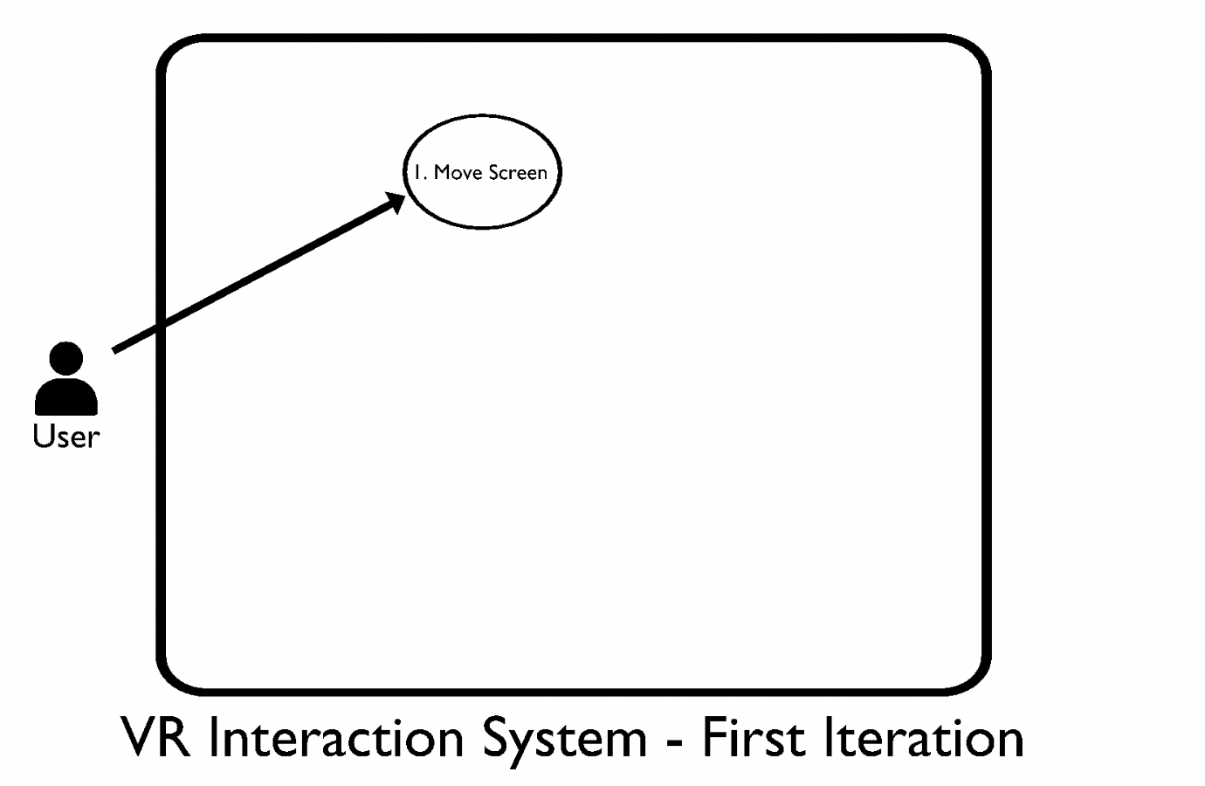
Figure 2 - Use Case Diagram Iteration 1
The above diagram displays a first iteration mapping of the VR interaction system. The primary use case I’ve decided to start with is the “Move Screen” use case. One of the core requirements I established from my survey was the ability to freely move and arrange the virtual screens, so this seemed an appropriate starting point.

Use Case 1 |  | Move Screen
Goal In Context |  | Moving a virtual screen from one position/orientation to a different position/orientation.
Preconditions |  | At least one virtual screen must exist.
Success Condition |  | The desired screen is in the desired position.
Actors |  | User – The individual using the system.
Trigger |  | User performs “Grab” input.
Description |  | The user should be able to perform an input on the VR controller of either hand, while hovering their hand over a desired virtual screen. The screen should then be “grabbed”, and should follow the position and rotation of the user’s hand as they move it to a new orientation. Once the user lets go, the screen should remain in the position in which they let go of it.
Main Flow
Step | Action |  | Alternate
1.1 | User performs “Grab” input.
1.2 | User grabs desired screen.
1.3 | Screen registered as “Grabbed”.
1.4 | User moves hand which is holding screen to desired position.
1.5 | User ends “Grab” input.
1.6 | Screen remains in place.

From this use case expansion table, we can extrapolate more use cases with which to fill out the diagram. For example, in order for the user to grab a screen, a screen must first exist, so we need a use case to add one. In that case, we also need a use case to delete screens the user no longer wants. We also need to add use cases for the Godot engine. When the user moves a screen, its position must be updated, and when they add or remove a screen, the system’s list of existing screens must be updated too.
This leads to the second iteration use case diagram, which adds the Godot engine as an actor, as well as including these new use cases.

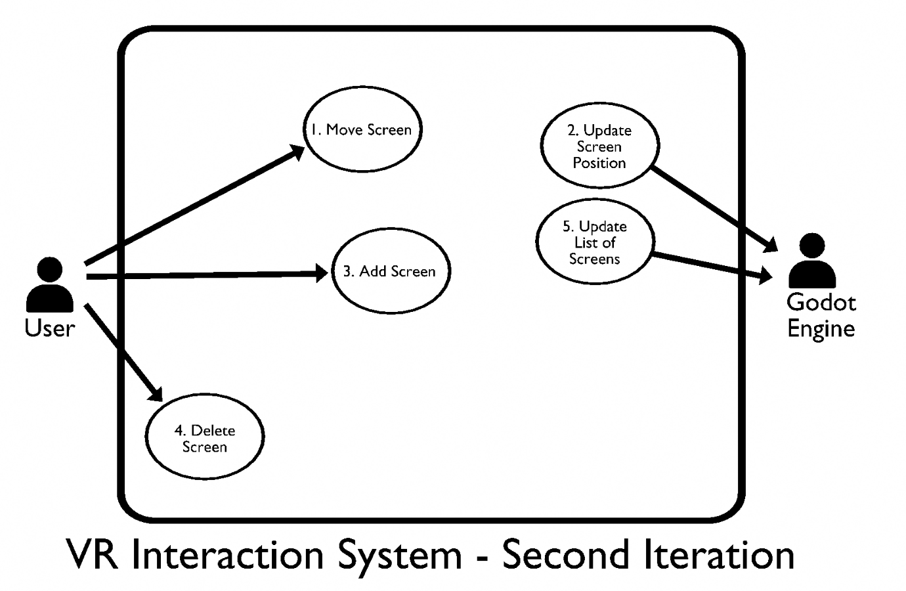
Figure 3 - Use Case Diagram Iteration 2
Now that these extra use cases have been established, they must be explained and expanded upon just like the first one.

Use Case 2 |  | Update Screen Position
Goal In Context |  | The tracked position of a virtual screen is updated as the user moves it.
Preconditions |  | N/A
Success Condition |  | The desired screen has its position updated to the desired position.
Actors |  | Godot Engine – Keeping track of screens and positions.
Trigger |  | Use Case 1.
Description |  | As Use Case 1 is carried out, the system should constantly update the tracked position of the selected screen to match the position of the hand the user is holding it with. When the user lets go, the system should stop updating the position, and lock the screen in place.
Main Flow
Step | Action |  | Alternate
1.1 | Use Case 1 started.
1.2 | System updates position of selected screen.
1.3 | System continues to update position every frame.
1.4 | When screen is let go of, System stops updating.
1.5 | System locks screen in place and keeps track of new position.

Use Case 3 |  | Add Screen
Goal In Context |  | Add a new virtual screen to the scene.
Preconditions |  | Maximum number of screens is not reached.
Success Condition |  | A new screen is added to the scene.
Actors |  | User – The individual using the system.
Trigger |  | User opens screen menu.
Description |  | The user opens the screen menu, and selects “add screen”. They then select the size and resolution of the screen. The system then creates the screen in front of them.
Main Flow
Step | Action |  |  | Alternate
1.1 | User opens screen menu.
1.2 | User selects “add screen”. |  |  | E.F. 1.2
1.3 | User selects what screen size they would like.
1.4 | User selects what screen resolution they would like.
1.5 | System creates new screen in front of user.
Error or Alternative Flows
Step | Action |  | Alternate
E.F. 1.2 | Maximum number of screens already exists.  “Add screen” option is greyed out, and user cannot select it.

Use Case 4 |  | Delete Screen
Goal In Context |  | Delete a virtual screen from the scene.
Preconditions |  | At least one screen exists.
Success Condition |  | The selected screen is removed from the scene.
Actors |  | User – The individual using the system.
Trigger |  | User opens screen menu.
Description |  | The user opens the screen menu, and selects “delete screen”. They then select the screen they want to remove. The system then deletes the screen.
Main Flow
Step | Action |  |  | Alternate
1.1 | User opens screen menu.
1.2 | User selects “delete screen”. |  |  | E.F. 1.2
1.3 | User selects what screen they would like to delete.
1.5 | System deletes the selected screen.
Error or Alternative Flows
Step | Action |  | Alternate
E.F. 1.2 | No screens currently exist.  “Delete screen” option is greyed out, and user cannot select it.

Use Case 5 |  | Update Screen List
Goal In Context |  | Update the list keeping track of the screens that exist.
Preconditions |  | N/A.
Success Condition |  | The list is up to date and contains all existing screens.
Actors |  | Godot Engine – Keeping track of screens and positions.
Trigger |  | User attempts to add or delete a screen.
Description |  | When Use Cases 3 or 4 are carried out, the screen needs to update the list of existing screens, adding or removing screens from the list as appropriate.
Main Flow
Step | Action |  | Alternate
1.1 | Use Case 3 or 4 started.
1.2 | System retrieves list of existing screens.
1.3 | System updates list to include correct screens.

With these use cases fully mapped out and explained, we can analyse them to get a further list of requirements.
- Users must be able to grab things with VR controllers.
- User must have a menu that lists screens and gives options to add or remove.
- System must keep a list of all screens currently active.
- System must keep track of position and orientation of all screens.

3.4 Initial System Specification
Combining the information established in the previous sections regarding user requirements, use cases, alternative solutions, and good practices for VR development, I have come to the following list of core requirements.

3.4.1 Functional Requirements
- The system should allow users to grab and manipulate VR object.
- The system should allow users to create and remove virtual screens/monitors.
- The virtual screens created by the system should stream from the user’s computer.
- The first screen should show what is on the user’s real screen.
- Screens beyond the first screen should stream from simulated additional monitors.
- The system should keep a list of active screens, which the user can view.
- The system should allow users to grab virtual screens, and move them around freely.
- The system should provide preset screen layout options that can be applied.
- The system should keep track of the position and orientation of each screen.
- The system should provide functionality to add or remove interactive elements that can be used to trigger shortcuts based on the currently active application.
- The system should allow users to freely choose the layout of these interactive elements.
- The system should allow users to choose what command or shortcut each interactive element will trigger.
- The system should provide a variety of different types of interactive elements to choose from, ranging from simpler to more complex to interact with.
- The system should allow the user to choose from a range of different surrounding environment options, ranging from very plain and simple, to more decorated.
- The user should be capable of moving around the 3D scene in order to better reach or see elements.

3.4.2 Non-Functional Requirements
- Surrounding environment options should not be overly distracting or engaging.
- System must maintain a consistent, high framerate and resolution to prevent VR sickness.
- Any user interfaces should be clean and minimalistic in design.
- Point-and-move teleportation should be a locomotion option to prevent sickness.
- Interactions should include auditory and tactile cues.

3.4.3 Appropriate Architecture
The correct architecture to use to model my system has been a difficult question. Many of the traditional models that I have worked with in the past, such as layered architectures, client-server architectures, or MVC based architectures, are not applicable. Working in a game engine presents an entirely different model. After researching the topic, I found that most applications developed using a game engine like Godot use a component-based architecture.
This is appropriate for a VR project like mine, as it allows individual objects, like the VR controllers, user object, and VR camera, to have different behavioural modules. This model supports reusability and flexibility in code, and more efficient management of complex VR interactions, like grabbing and manipulating objects.

3.5 Conclusions
After a number of different methods of obtaining and analysing requirements, I was able to conclude a well-defined list of functional and non-functional requirements for the system. Additionally, based on this set of requirements, I was able to research and identify an appropriate architecture for the system to follow. Now that the system and its requirements have been analysed, I must design the system around them.

4. System Design

4.1 Introduction
Once all my requirements were established under the functional and non-functional headings, I needed to translate them into a system design. The first step was grouping the requirements into logical subsystems. For example, all requirements related to the virtual screens could be grouped together into the “Virtual Screen System”. With these different systems, and the component-based architecture I selected in the previous section, the next step was to determine the main components needed for each system to work. The “Core System” (i.e. the main components needed for basic VR functionality), for example, includes components for the VR controllers, the VR camera, and the user object. Having mapped out some of this using UML use case diagrams while analysing the requirements initially, I was able to identify and understand user interactions, and how components would need to interact.

4.2 Software Methodology
The only software development methodology that I’ve worked with before is the Agile methodology, so it would seem that Agile would be an obvious choice. However, Agile is a collaborative methodology, meant for a team of developers working together in sprints. Because I am a solo developer for this project, I cannot simply use Agile as it is. With this in mind, I will be using an adapted version of the Agile methodology, intended for a single developer. Even without the collaborative focus, I can still use the core Agile concepts of test-driven development, working in small sprints, and frequent contact with the customer or end user. Where Agile would normally have stand-up, sprint planning, and retrospective meetings, I can substitute periodic reviews of my own progress, and my meetings with my project supervisor.

4.3 Overview of System
There are two main parts to cover as part of my system overview. These are the logical architecture, the major parts of the system and how they relate to each other, and the physical infrastructure, the hardware and platforms the system is going to run on. Additionally, I must also consider the production environment, and how the system might be deployed.

4.3.1 Physical Infrastructure
For a VR app, physical infrastructure has an obvious starting point: the VR equipment. This will be a VR headset, which the user must use to see and hear the application, as well as two VR controllers, one for each hand, which will let them interact with the system. Another requirement for hardware will be the computer that the application will run on. Some VR applications will run natively on a standalone headset like the Meta Quest, but this application needs to interface with drivers, and so will be run on a computer. Additionally, in terms of software required to platform the system, the Godot game engine, as well as its development environment, will handle the bulk of the work. As described previously, a virtual display driver will also be needed to simulate the additional virtual monitors. Lastly, and this is partially included with the computer in the hardware concerns, this system will need the Windows operating system.

4.3.2 Logical Architecture
This is where the logical subsystems described earlier in this section come into consideration. The application will be divided into several subsystems based on the tasks that the different components must carry out. For example, the “VR Interaction System” will include the VR controllers, and will manage touch-based input, grabbing and manipulating objects, and receiving haptic feedback via controller vibration.

VR Interaction System
This will include the VR controllers, and manage inputs from the buttons and joysticks on them, as well as tracking their position. It will facilitate the ability to grab and manipulate objects in the 3D scene, as well as receiving haptic feedback. As well as the VR controllers, which make up the input, this system will also be responsible for the other side, the output. This means the VR headset. Similarly to the controllers, this system will need to track the position and orientation of the headset, and thus the user’s head, in order to properly display what they should be seeing, and to track what they’re looking at.

Virtual Screen System
This subsystem will manage and track the virtual screens as they are created, deleted, and moved. On a deeper level, it will also include the code allowing each screen to retrieve what it should be displaying, as well as interacting with the display driver to support the addition and deletion of the screens as previously mentioned.

Environment System
This system will allow the user to select which environment they would like to use, and will facilitate the switching of the models and textures of the current environment with the new one. It will also manage the performance concerns of the environments. This will include aggressive culling, meaning that the system will cease to render environment objects that are out of view of the user.

Interactive Shortcut System
This system will track the interactive VR shortcut elements described previously. This includes tracking what kinds of interactive elements are present in the scene, what positions they are in, and most importantly, their state. If the element is a lever, the system needs to know if it has been pulled or not. This system will also track which commands and shortcuts that each interactive element is supposed to trigger when its condition of “triggered” is met.

UI and Menu System
This system will define how the user can interact with the UI and menus. The user will need to be able to select menu options in order to do basically anything in the application. This includes adding and removing virtual screens and interactive elements, moving from the title/menu screen into their virtual workspace, and any other choices or options they need to select. This will be facilitated via the convention for VR: a point-and-click system, where the user’s pointer finger casts a line out in front of it, and pressing a button on the VR controller triggers whichever button that line is intersecting with.

Rendering System
This will be the system that controls how the entire application is drawn onto the VR headset’s output display. This is mostly handled by the game engine, but will need a lot of input from myself as well. Rendering is one of the most expensive processes for an application like this, so it is important that it is as optimized as it can be.

These divisions describe the core subsystems for the features and functionality set out in the requirements in the previous section. These are the most complex and detailed systems. However, they do not represent all of the functionality the system requires. The logical architecture will also include several smaller subsystems for changing system settings like volume or VR comfort settings, and transitioning between scenes (like going from the main menu to your workspace).

4.3.3 Deployment and Production Environment
The deployment of this application, considering the fact that it is developed inside a game engine, and the fact that it doesn’t require any kind of online or server-based interaction, should be quite simple. The application will be exported from the Godot engine as a Windows executable. Once exported, the application should run entirely on the laptop, with no external network dependency. In order to run, the application will need to be launched on the user’s Windows computer, along with a VR headset being connected to the computer.

4.4 Design System
This section is where I will lay out my chosen design methodology, as well as the actual design of the system, based on the requirements, architecture, and software considerations that I have explored in the last few sections.

4.4.1 Design Methodology
Extending from my chosen system architecture, component-based architecture, my design methodology will also be component-based. Component-based design is a design methodology that builds applications from independent, reusable components. An approach like this promotes reusability and flexibility in design, as well as being highly compatible with the tools provided by a game engine, wherein everything is defined as a type of component, whether it be GameObject or Resource. Using component-based design to build off of my architecture, I will expand on the logical subsystems laid out previously, building them into architectural, component, and interaction diagrams, as well as explaining how each part of the design satisfies the functional and non-functional requirements described before.
4.4.2 High-Level Architecture
In this section, I’ll expand upon the logical subsystem division I described previously. In the last section, I wrote about the subsystems and how they work individually, but as part of the design, they need to work together, and have some overlap, in order to achieve functionality.
At the core of the system is the VR interaction system. This system facilitates the user existing in the virtual space, and their ability to use the UI and menus, their ability to add, delete and move virtual screens, their ability to see and move around the environment, and their ability to interact with and trigger the interactive shortcut elements. From here, each of the elements have further overlap.
The UI and menus will be a key element in adding and removing screens and interactive elements, as well as selecting and updating the commands on the interactive shortcut elements. Any option or choice that the user is presented with will have to go through this system, which ties it closely to each other system.
The rendering system is linked tightly to all of the other systems, as each system needs to have its elements rendered and displayed to the user. Particularly concerned with this though is the Environment system, because the rendering of the environment will need to be tightly optimised via techniques like occlusion culling. The same goes for the virtual screen system. Capturing the contents of several screens on each frame of the system and rendering them in the 3D scene will be an expensive process, so it will be a necessary task to track which screen the user is currently looking at and lower the frame rate and resolutions of other screens.
The interactions between these systems can be better visualised via this high-level system diagram:

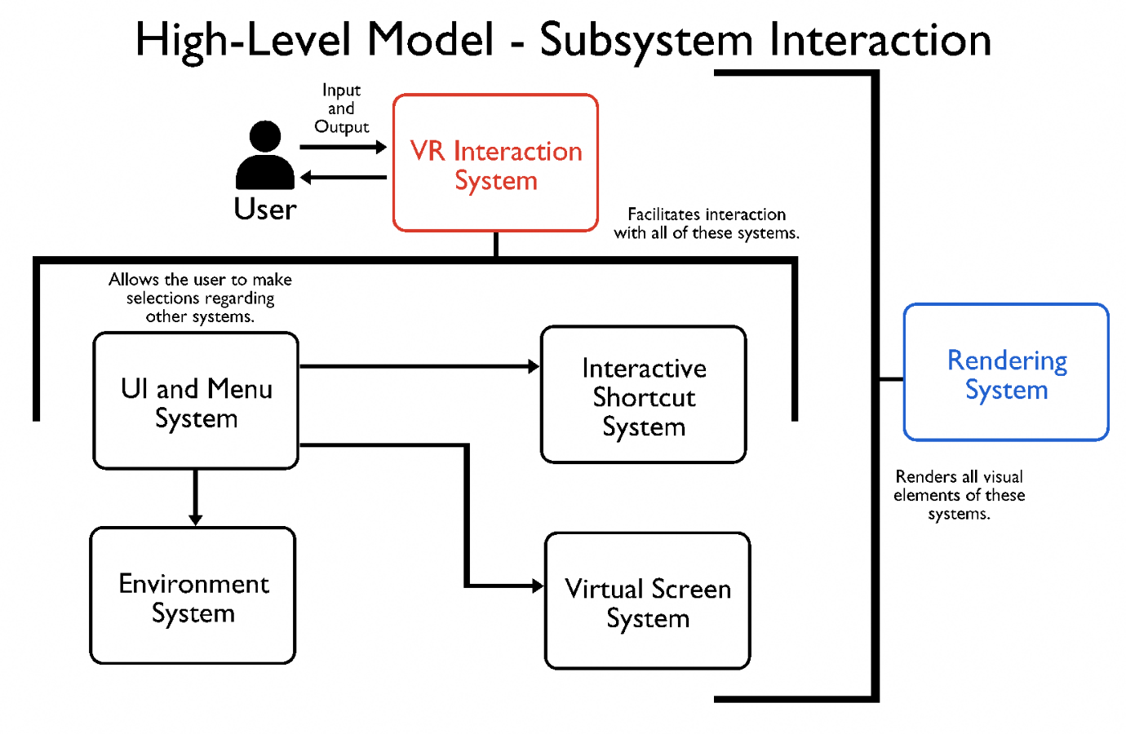
Figure 4 - High Level System Architecture Diagram

Going forward from here, I should clarify a bit more about how Godot projects are structured, so that it is easier to understand how this project will be developed going forwards. Godot projects are built primarily from scenes and nodes. A Godot project is a tree of scenes, and a scene is a tree of nodes.
For example, the scene containing the virtual workspace will have a root node, which will be the whole scene. It will then have child nodes for the player, and the environment. The player node will have its own child nodes for the VR camera, and the two VR controllers. Each node also has its own type. Certain types have pre-defined behaviours, like a 3D mesh node, and some are just a series of information, like a point in 3D space. Having explained this node-based structure will help me to better expand upon the lower-level architecture as I continue.

4.4.3 System Design – Use Case Expansion
With a basic structure and subsystems laid out, the next step is to design and analyse specific system behaviours, interactions, and functionalities, on a deeper level. This section will include a lot of the diagrams typical to software design, such as use cases, component diagrams, and sequence diagrams.
Considering use cases first, I already expanded on a lot of the use cases for this system, at least with regards to the VR screen system. In that section, I used the use cases to further build and define requirements. Here, the reason for the use cases is more about exploring how the user will interact with the system, and what kind of behaviours need to be in place to support that. Here is an updated use case diagram, which adds further interactions on top of the ones defined previously.
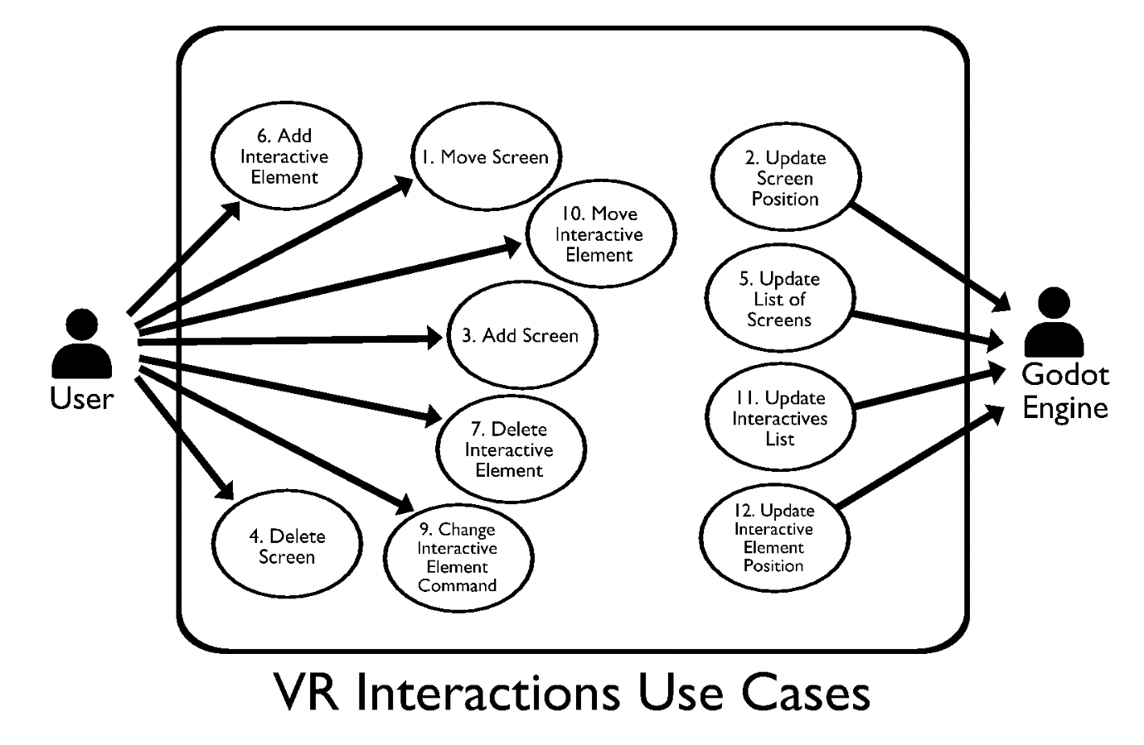
Figure 5 - Fully Realized Use Case Diagram
This diagram expands on the previous set of use cases by adding ones related to the interactive shortcut system. These new use cases have somewhat different flows to the ones previously established.
Use Case 6 |  | Add Interactive Element
Goal In Context |  | Add a new interactive shortcut element to the scene.
Preconditions |  | Current number of interactive elements is less than the maximum.
Success Condition |  | A new interactive element has been added and placed.
Actors |  | User – Using and interacting with the system.
Trigger |  | User selects interactive shortcut menu.
Description |  | The user selects the interactive shortcut menu and selects “add new”. The user then selects what kind of element (button, switch, etc.), and where they want it to be. The user selects what command they would like it to trigger. The system then creates the desired element in the desired spot.
Main Flow
Step | Action |  | Alternate
1.1 | User selects interactive shortcut menu.
1.2 | User selects “add new”. |  | E.F. 1.2
1.3 | User selects what kind of element they’d like.
1.4 | User selects placement for the element.
1.5 | User selects what command they’d like it to trigger.
1.6 | System creates new element in desired location.
Error Flow
Step | Action |  | Alternate
E.F. 1.2 | Maximum number of interactive elements already exists.  The “add new” button is greyed out, and the user cannot select it.

Use Case 7 |  | Delete Interactive Element
Goal In Context |  | Remove an interactive shortcut element from the scene.
Preconditions |  | At least one interactive element exists.
Success Condition |  | The desired interactive element has been removed.
Actors |  | User – Using and interacting with the system.
Trigger |  | User selects interactive shortcut menu.
Description |  | The user selects the interactive shortcut menu and selects “remove item”. The user then selects element they want to remove. The system then removes the desired element.
Main Flow
Step | Action |  | Alternate
1.1 | User selects interactive shortcut menu.
1.2 | User selects “remove element”. |  | E.F. 1.2
1.3 | User selects which element they’d like to remove.
1.4 | System removes the selected element.
Error Flow
Step | Action |  | Alternate
E.F. 1.2 | No interactive elements currently exist.  The “remove item” button is greyed out, and the user cannot select it.

The next use case, which is the one for moving an interactive element, is the one that differs the most from its virtual screen counterpart. The screens can be moved simply by grabbing them, but for many of these elements, grabbing them will be how they are activated or triggered. Instead, a different flow must be followed.

Use Case 8 |  | Move Interactive Element
Goal In Context |  | Move an interactive element to a different location.
Preconditions |  | At least one interactive element exists.
Success Condition |  | The desired interactive element has been removed.
Actors |  | User – Using and interacting with the system.
Trigger |  | User selects interactive an interactive shortcut.
Description |  | The user selects the interactive they wish to move, selects “move”, and then the location they wish to move it to. The system then moves it to the new location.
Main Flow
Step | Action |  | Alternate
1.1 | User selects an interactive element.
1.2 | User selects “move”.
1.3 | User selects the location they’d like to move it to.
1.4 | System moves the selected element to the selected location.

Use Case 8 |  | Change Interactive Element Command
Goal In Context |  | Change the command triggered by an interactive element.
Preconditions |  | At least one interactive element exists.
Success Condition |  | The desired interactive element has had its command changed.
Actors |  | User – Using and interacting with the system.
Trigger |  | User selects interactive an interactive shortcut.
Description |  | The user selects the interactive element of which they wish to change commands, then selects “change command”, then selects a new command. The system then updates the command.
Main Flow
Step | Action |  | Alternate
1.1 | User selects an interactive element.
1.2 | User selects “change command”.
1.3 | User selects the new command they’d like to use.
1.4 | System updates to new command.

I’ve chosen to exclude the use case expansions for the remaining use cases, numbers 10 and 11, as they are almost identical to numbers 2 and 5, only changing what kind of element the system is updating a list of.
With these use cases expanded upon, I now have a clearer image of some of the architecture and components that will be required in my design.

4.4.4 System Design – Components
The next step in design is to establish a list of components. As mentioned before, it is a fundamental principle of component-based design that components are small, reusable pieces of software, allowing for greater reusability and flexibility. As such, many of the system components are themselves comprised of smaller components, which fits well with Godot’s “tree of nodes” structure system.
In this section, I will list some of the key system components, and some of the key components that comprise those components. I will also show some UML component diagrams to demonstrate how these components interact with one another. Components for the UI and menu system are scattered through the components, wherever something needs a menu to be interacted with, and the rendering system is mostly made up of Godot settings and configurations, and so isn’t represented as its own list of components.

VR Interaction System
- User Body – This is the component that represents the user’s virtual avatar in the 3D scene. It manages all of the user’s interactions with the virtual world. It acts as the origin point for the user in the 3D scene.
  - VR Camera – This component tracks the user’s head movements, determines what parts of the 3D scene they should be seeing based on head position, and then displays it on the VR headset lenses.
  - VR Hands – These components, a left variant and a right variant, are responsible for the user’s interactions with the world. Any inputs the user wants to make, anything they want to pick up or move, are all the responsibility of these.
    - VR Pickup – This component is responsible for allowing the user to pick up and grab items. It defines the 3D position on the hand that an item should snap to when grabbed, and is responsible for interacting with the grabbed item.
    - VR Movement – If the user makes inputs on the joysticks on the two VR controllers to move and turn, this component is the one responsible for translating those inputs into the correct movement.
    - VR Pointer – This will be a straight line cast forward from the hand’s pointer finger, enabling users to interact with menu options by pointing at them and performing a controller input.
    - Menu – This component will represent a small menu that will float above one of the user’s wrists, dependent on if they are right or left-handed. It will provide options for accessing settings, as well as managing virtual screens and interactive shortcuts.

Virtual Screen System
- Screen Manager – This component will be responsible for managing the virtual screens. It will keep a list of active screens, their indexes, and their sizes. It will be responsible for creation and deletion operations.
  - Driver Helper – This child component of the Screen Manager will be used to interface with the Virtual Display Driver in order to facilitate the creation and deletion of the screens.
- Virtual Screen – The component that represents the actual screens themselves. This component will be instanced when a new screen is created, and will be issued an index number by the screen manager.
  - 3D Mesh Plane – This component has no code of its own, but is simply the square or rectangular plane on which the virtual screen’s content will be displayed.
  - VR Pickable – This component is what will allow the virtual screen to be grabbed and moved by the user, is part of what defines how the screen will snap to the user’s hand, and communicates with the VR Pickup component.

Interactive Shortcut System
- Shortcut Slot – A simple component that defines a location where a shortcut element can be placed. It will be able to track whether it is currently occupied or not.
- Shortcut Manager – Just like with the screen system, there must be a component to keep track of each shortcut element, what commands they’re running, and where they are.
- Shortcut Element – This component will be the actual element itself, which allows the user to interact with it to trigger a command.
  - VR Pickable – This will be a reuse of the same component as in the Virtual Screen. It will be what allows the user to interact with the shortcut elements, like grabbing a lever for example.
  - Command Handler – This component will be what triggers the command when the shortcut element meets the activation condition. This component will differ based on what kind of command is assigned.

The above list represents the core components necessary for the system’s functionality. There will be other components present, as well as child components for the ones that I have listed, but these are excluded here for the sake of brevity, as an exhaustive list would take up several pages.
Now that the components are listed and their relations described, they can be laid out on a component diagram. In some places, a component is the child of another even though neither offers an interface to the other. In these cases, I have used the UML dependency relation to show the relationship.

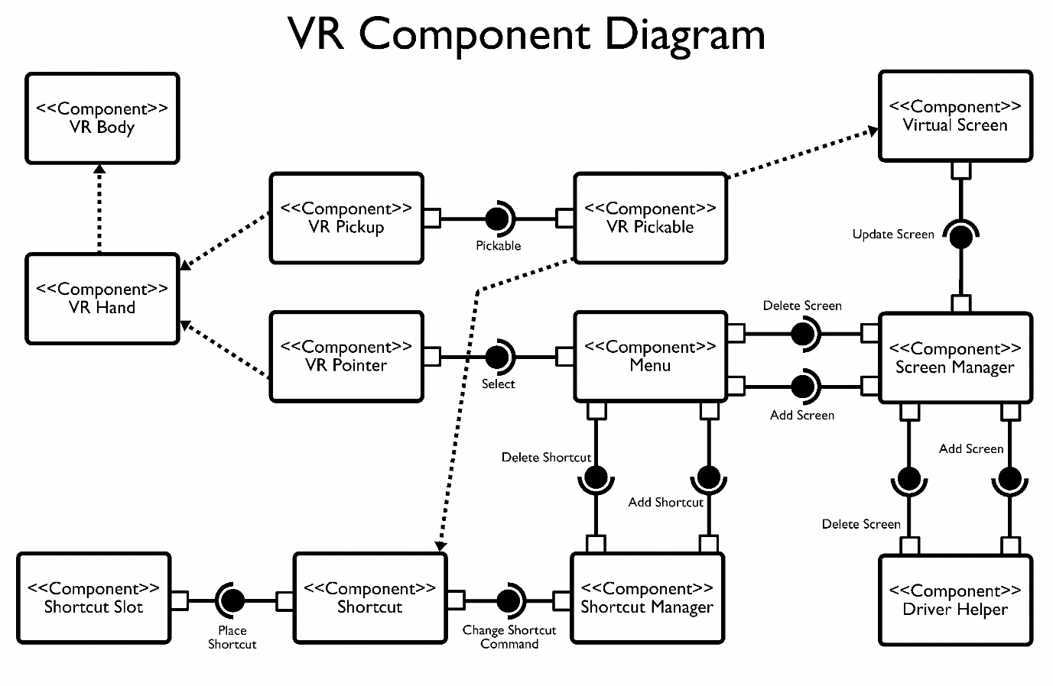
Figure 6 - VR Component Diagram
4.4.5 System Design – Sequence Diagram
Sequence diagrams are an important tool in software design, as they show how the system actually behaves in action over time, rather than just showing a static structure. Because of this, I have mapped out one of the key use cases as a sequence diagram to better show how the components will interact with one another in more granular detail.

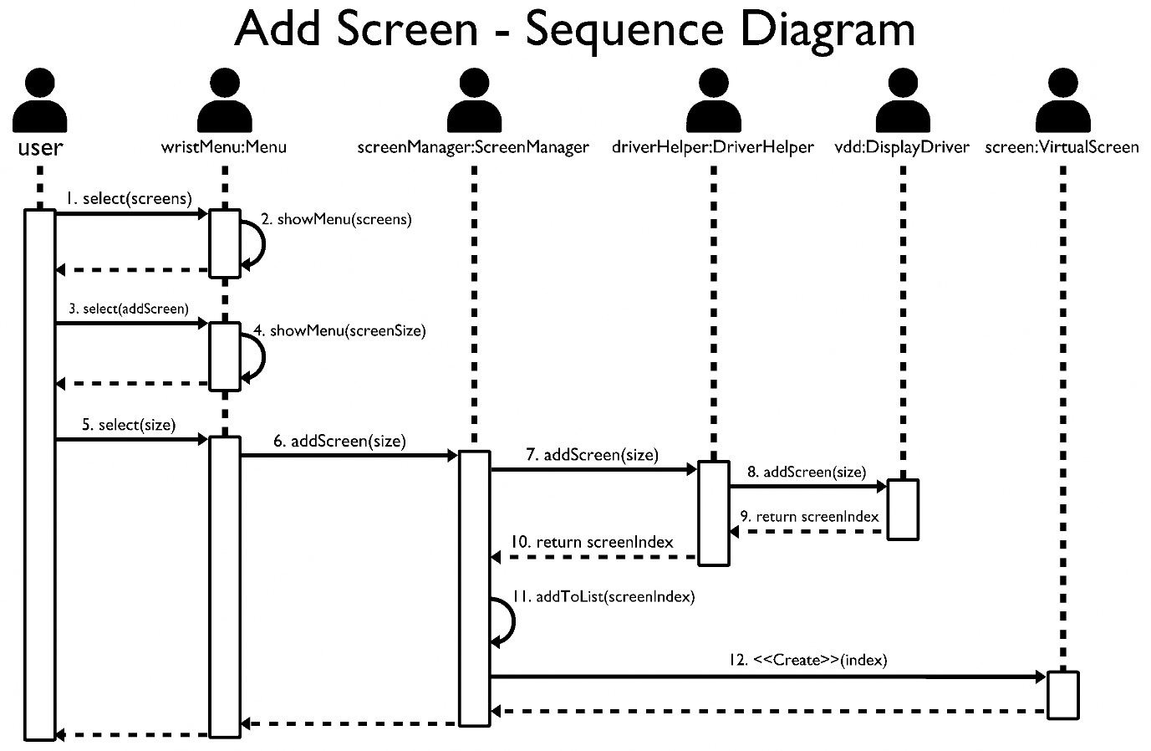
Figure 7 - "Add Screen" Sequence Diagram

This diagram represents the sequence followed for the “Add Screen” use case. Following the steps, it can be better visualized how each component communicates and makes use of the interfaces laid out in the component diagram. The flow represents the user’s selection to look at screens, add a screen, and select a size, and then represents the system’s internal interactions to communicate with the display driver to start simulating a new screen, and instantiate a new screen object to stream from it.

4.4.5 System Design – Other Points
There are a few other key points of the system design that the other points haven’t covered. This is because, due to the application’s nature as a 3D VR app, there are elements important to the overall design of the system that remain outside of any one component or subsystem, or even don’t contain any code at all.
One such consideration is polygon counts. In a 3D rendered environment, everything is made up of 3D models. Each 3D model is a collection of vertices, points in 3D space. These vertices come together to form polygons, like the faces of a cube. The more polygons a model has, the more detailed and complex it can look. However, with an increased polygon count also comes a greater performance cost. Models with a high polygon count are very expensive for the system to render, so it’s very important to balance the look and feel of the system with how easy it will be for the system to render. There are a number of techniques that I will employ to make models with lower polygon counts look better, such as using detailed normal maps. A normal map is a 2D texture that tells the system to render the model differently, depending on the content of the texture. This can be used to simulate additional depth and detail where there is none.

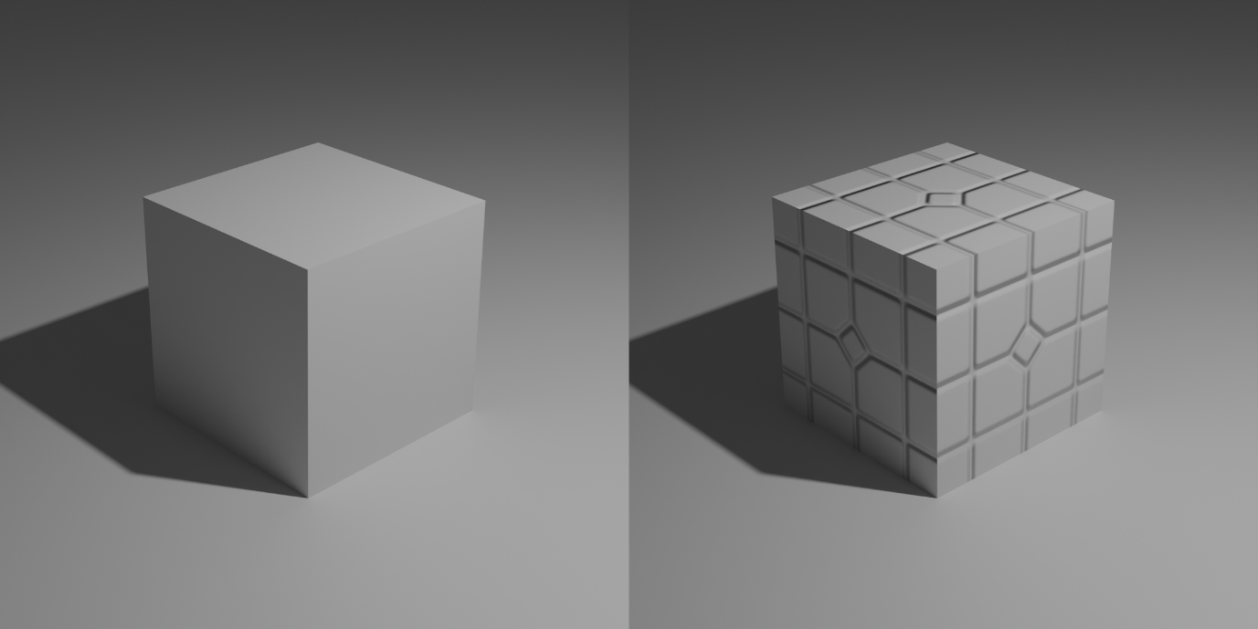
Figure 8 - On the left, a plain cube. On the right, the same cube with a normal map applied.
Additionally, to save on rendering costs, the system will use Godot’s baked lighting, where all details regarding how the lighting in the scene is set up is calculated in advance and baked into the scene, rather than being calculated in real time. The system will also make use of Godot’s occlusion culling settings, where objects can be designated as something that the system is allowed to stop rendering when it is out of sight of the user, such as if it is out of frame of the camera, or behind another object.
Lastly, the system will also track the direction the user’s head is facing to determine which virtual screen they are looking at. This screen will be designated the primary one, and any others will have their refresh rate limited while the user isn’t looking at them.

4.5 Conclusions
With the end of this section, I have laid out the core design of the system. The key components for major functionalities have been listed, and mapped out to show the interfaces they offer to each other, and the way they make use of these interfaces. I have also established key use cases, and how their flow will be required to play out, as well as representing one of the most important ones, “Add Screen” on a sequence diagram, in order to further show component interaction in more granular detail. With this design step complete, I now know the structure of the system. In the following sections, I will build on this, by discussing testing, implementation, and how I can proceed in future. It is likely that some of the design details discussed here will change and evolve as development continues, so having a structure like this as a reference point is key.

5. Testing and Evaluation

5.1 Introduction
With the system design in place, it will be important as the system is implemented to ensure that it all works correctly, and produces the expected results for each and every possible operation. With that in mind, it will be important to plan tests for the system as a whole, as well as each of the logical subsystems. There are a number of different kinds of tests and test strategies, so I’ll need to choose carefully which tests to use for each part of the system and how to run them. For example, the VR interaction system will need to have manual unit tests to ensure that the controllers and headset track the user’s hands and head correctly. I will be using the Godot plugin GDUnit4 to help with testing. The plugin is capable of simulating user input, as well as spying on functions to ensure they were called correctly, and generating random inputs to test edge cases.

5.2 Plan for Testing
In this section, the plans for how I’ll test each different part of the system will be explained. Each system has different needs in terms of testing, and different tests, and different kinds of tests, should be applied to each one. I’ll mention for each subsystem what is being tested, how it’s being tested, and what the success and failure criteria are for each one. Testing for each component will incorporate both black- and white-box testing, as I will have written all of the components, and will have access to the code.

5.2.1 Testing – VR Interaction System
This subsystem handles user input, meaning that the tests ensuring that it works properly will be very important. Thankfully, because the finer details of the inputs handled by the VR interaction system are part of the Godot XRToolkit addon and the OpenXR plugin, they have their own tests, and I need only test how they interact with the other systems. The main thing to test here will be the grabbing functionality, i.e. the ability to pick up and move objects. The two main cases here to test are the ray-cast menu selection, and the ability to grab items.

VR Hand 01 | Select Menu Item
Description: | Ensure the VR menu pointer can select menu items.
Preconditions: | Menu item exists.
Input: | VR controller trigger.
Success Condition: | The relevant menu option should be selected and the input read.
Fail Condition(s): | Input fails to be read.
Steps:
1. Point VR ray-cast pointer at a menu option, and perform trigger input.
2. Input is detected and registered.

VR Hand 02 | Grab Item
Description: | Ensure the VR hand can grab items.
Preconditions: | Grabbable item exists.
Input: | VR controller grip.
Success Condition: | The selected item should be grabbed.
Fail Condition(s): | Input fails to be read.
Steps:
1. Hover VR hand over grab point on grabbable item.
2. Input is detected and registered.
3. Item grabbed.

5.2.2 Testing – Virtual Screen System
There are three key parts of the virtual screen system to test. Those are the screen manager, the driver helper, and the screens themselves. For the manager, I need to test that it can successfully create a screen of the desired size, that it can delete a screen that the user has chosen, and that it communicates correctly with the driver helper. I also need to ensure that it can handle invalid inputs, such as a negative screen size, being passed to it. For the driver helper, I need to ensure that it communicates properly with the driver, and that it returns the correct information to the screen manager. Lastly, for the screens, I need to make sure they’re properly grabbable, and that they display the correct content.

Screen Manager
For the screen manager, it seems appropriate to use unit and integration tests to evaluate its ability to create and delete screens. Unit tests can verify individual methods and functions, and integration tests can validate its communication and cooperation with the driver helper. A test script can be written that will pass a number of different screen sizes to it in a row, as well as telling it to delete each screen afterwards. This script can check that it is creating the correct screens at the correct sizes, as well as disposing of them afterwards. The scope for testing on the screen manager includes screen creation and deletion, retrieval of active screens, and communication with the driver helper. I’ll lay out some key test cases here.

Screen Manager 01 | Create Valid Screen
Description: | Ensure the screen manager can create a new screen.
Preconditions: | Maximum number of screens do not exist.
Input: | A valid screen size (1920x1080).
Success Condition: | A new screen of the input size is created in the 3D scene.
Fail Condition(s): | No screen is created, screen of wrong size is created.
Steps:
1. On screenManager, call createScreen((1920,1080)).
2. Size is passed to driverHelper.
3. Size is passed to virtual display driver, which begins simulating a new monitor at an OS level. Returns an index number for the new screen.
4. The screenManager registers the index number, and instantiates a new virtualScreen with the correct size and index number.

Screen Manager 02 | Delete Screen
Description: | Ensure the screen manager can delete a screen.
Preconditions: | At least one screen exists.
Input: | Index number of desired screen (2).
Success Condition: | The selected screen is deleted.
Fail Condition(s): | Screen is not deleted, wrong screen deleted.
Steps:
1. On screenManager, call deleteScreen(2).
2. The matching virtualScreen instance is deleted from the scene.
3. Index number is passed to driverHelper.
4. The driverHelper passes the index to the virtual display driver, which stops simulating the matching screen.
5. The screenManager removes that index number from its list.

Screen Manager 03 | Create Invalid Screen
Description: | Ensure the screen manager can handle being passed an invalid screen size.
Preconditions: | Maximum number of screens do not exist.
Input: | A valid screen size (-10x3751).
Success Condition: | No new screen is created, component returns an appropriate error.
Fail Condition(s): | Screen is created.
Steps:
1. On screenManager, call createScreen((-10x3751)).
2. Size is recognized as invalid by screenManager, which throws an error.

Screen Manager 04 | Access Existing Screens
Description: | Ensure the screen manager can access a list of all existing screens.
Preconditions: | At least one screen exists.
Input: | N/A
Success Condition: | List of all active screens is returned.
Fail Condition(s): | Nothing is returned, anything other than list of screens returned.
Steps:
1. On screenManager, call getScreens().
2. The screenManager accesses the list of screens and returns it.

A potential risk for these tests is that errors from the virtual display driver itself could impact the results, even though the goal is just to test the screen manager. For this reason, it might be a good idea to use a simulated driver for test purposes.

Driver Helper
The driver helper should also have its own integration tests, which will ensure that it communicates properly with the virtual display driver. This should include tests for adding screens, and for deleting them.

Driver Helper 01 | Add Screen
Description: | Ensure the driver helper can tell the driver to start simulating a screen.
Preconditions: | Maximum number of screens do not exist.
Input: | A valid screen size (1920x1080).
Success Condition: | The driver starts simulating a new monitor and returns an index.
Fail Condition(s): | No monitor is simulated, no index is returned.
Steps:
1. On driverHelper, call createScreen((1920,1080)).
2. Size is passed to virtual display driver.
3. Virtual display driver begins simulating a new monitor at an OS level. Returns an index number for the new screen.

Driver Helper 02 | Delete Screen
Description: | Ensure the driver helper can tell the driver to stop simulating a screen.
Preconditions: | At least one screen exists.
Input: | Index number of desired screen (2).
Success Condition: | The selected screen is deleted.
Fail Condition(s): | Screen is not deleted, wrong screen deleted.
Steps:
1. On screenManager, call deleteScreen(2).
2. The matching virtualScreen instance is deleted from the scene.
3. Index number is passed to driverHelper.
4. The driverHelper passes the index to the virtual display driver, which stops simulating the matching screen.
5. The screenManager removes that index number from its list.

Virtual Screen
Because most of the complex logic related to the screen system resides outside of the screens themselves, the necessary tests for the screens themselves are limited. The screens only really need unit tests that will make sure that they are displaying the correct content, and integration tests to ensure they can be picked up correctly.

Virtual Screen 01 | Content Display
Description: | Ensure the virtual screen shows the correct content.
Preconditions: | Screen exists.
Input: | N/A.
Success Condition: | The screen shows the expected content.
Fail Condition(s): | The screen shows something outside the expected content.
Steps:
1. Open a new application, and drag the window over to the monitor that the virtual screen is streaming.
2. Verify that it displays as expected.

Virtual Screen 02 | Pick Up
Description: | Verify the screen can be picked up and moved around.
Preconditions: | Screen exists.
Input: | Controller grip button.
Success Condition: | The screen is picked up and can be moved around.
Fail Condition(s): | The screen is not picked up, cannot be moved around.
Steps:
1. Move one hand controller to the grab point on the screen, press the grip button.
2. The screen should then be grabbed, and can be moved around.

5.2.3 Testing – Interactive Shortcut System
The interactive shortcut system needs its own set of tests. This system is composed primarily of the interactive element, the shortcut manager, and the command handler. These need to have a similar set of unit and integration tests to the screen system.

Shortcut Manager
Shortcut Manager 01 | Create Shortcut
Description: | Ensure the shortcut manager can create a new shortcut.
Preconditions: | Maximum number of shortcuts do not exist.
Input: | A valid shortcut selection (horizontal_switch).
Success Condition: | A new shortcut of the desired type is created in the 3D scene.
Fail Condition(s): | No shortcut is created, shortcut of wrong type is created.
Steps:
1. On shortcutManager, call createShortcut(horizontal_switch).
2. The shortcutManager registers the index number, and instantiates a new interactiveShortcut with the correct type and index number.

Shortcut Manager 02 | Delete Shortcut
Description: | Ensure the shortcut manager can delete a shortcut.
Preconditions: | At least one shortcut exists.
Input: | Index number of desired shortcut (2).
Success Condition: | The selected shortcut is deleted.
Fail Condition(s): | Shortcut is not deleted, wrong shortcut deleted.
Steps:
1. On shortcutManager, call deleteShortcut(2).
2. The matching interactiveShortcut instance is deleted from the scene.

Interactive Shortcut
Interactive Shortcut 01 | Trigger Shortcut
Description: | Ensure that the shortcut’s trigger mechanism can be activated.
Preconditions: | At least one shortcut exists.
Input: | Depends on the shortcut – a lever should be pulled, a button pressed, etc.
Success Condition: | The mechanism works and is detected by the shortcut.
Fail Condition(s): | Mechanism does not work, is not detected.
Steps:
1. Perform input to trigger shortcut (pulling lever, pressing button, etc.)
2. Verify that input has been received and shortcut recognises it.

Interactive Shortcut 02 | Trigger Shortcut Command
Description: | Ensure that when the shortcut’s mechanism is activated, it tells the command handler to run the command.
Preconditions: | At least one shortcut exists.
Input: | Depends on the shortcut – a lever should be pulled, a button pressed, etc.
Success Condition: | Input received, command is run.
Fail Condition(s): | Input not received, command not run.
Steps:
1. Perform input to trigger shortcut (pulling lever, pressing button, etc.)
2. Shortcut calls function on command handler.
3. Command handler runs assigned command.
4. Verify command has been run.

Command Handler
Command Handler 01 | Run Command
Description: | Ensure that the command handler can run its command.
Preconditions: | At least one shortcut exists.
Input: | Depends on the shortcut – a lever should be pulled, a button pressed, etc.
Success Condition: | The shortcut runs its command.
Fail Condition(s): | The command is not run.
Steps:
1. Pass a function call to the command handler.
2. Command handler runs its command.
3. Verify command has been run.

5.2.4 Testing – Test Cases Conclusion
With these test cases mapped out for some of the core system functionalities, I have the start of a test plan beginning to form. For each component, testing can only be considered to have passed once all of the listed test cases have been run and met their success conditions. To create an exhaustive list of all possible test cases here would be impractical, and far too long, so for now I will simply describe some other key elements that must be tested, and move on to the next section.
Firstly, the menus will need unit tests that ensure that each button and option within them is selectable. They will also need integration tests that ensure that they can pass the correct commands to the correct linked components like the screen and shortcut managers. Next, I will need unit tests that confirm that occlusion culling, i.e. that objects are actually being un-rendered when out of frame. Additionally, there will also be certain things that need testing that don’t fall into any of the subsystems, or into any code or programming related elements at all. For example, I’ll need to test that collision is set up correctly on the virtual environment to prevent the user from falling through the floor.
I would also like to perform stress testing on the system. For example, I will create a test script that captures the frame rate the application is running at, and take note of how that frame rate is doing when I have different numbers of virtual screens running at the same time.

5.2.6 Testing – E2E
End-to-end testing is the most comprehensive and expensive kind of testing. This can only be done when all of the core systems are in place, and will require users or testers to play out full scenarios and use cases to ensure that all of the subsystems and components work properly together, in their interactions, and as a complete system.

5.2.6 Testing – Schedule
A good test plan includes a schedule for when the tests will be carried out. However, since development has only started, and I’m not certain how it will progress, I can’t put together a detailed plan now. I’ll discuss this further in Chapter 7, where I’ll break down plans for future development, and include a Gantt chart to plan the progression of the project. I will include scheduling plans for the tests there.

5.3 Plan for Evaluation
On the surface, evaluation seems to mean the same thing as testing. However, this is not true. Where testing ensures the system is free of bugs and errors, and that it meets functional and non-functional requirements, evaluation will ensure that the software meets the needs of the user, and that it is performant and easy to use.
As part of my evaluation plan, I’ll identify which aspects of the system that need to be judged, how I’ll judge them, and then lay out evaluation methodologies for the logical subsystems.

5.3.1 Aspects for Evaluation
It is important to consider which aspects of the system to evaluate here. I’ll focus mostly on how the system impacts the user, and how easy and efficient it is for them to use the system. Aspects to be evaluated will include:
- Usability – Nielsen’s 10 Heuristics, to be compared against alternative solutions.
- Performance – Frame rate of system and of virtual screens.
- User Comfort – VR sickness is a major consideration.
- Reliability – Ensure the display driver and other systems work consistently.
- User Satisfaction – Are users actually happy to use the system?
- Accuracy of Interactions – Ensure that virtual hand and head positions line up correctly with real world controllers and headset.
- Suitability – How easy is it to use for the intended purpose: long periods of concentrated work?

5.3.2 Evaluation Methods
There are a number of different methods for evaluating the system that I’ll need to consider. For example, through the use of heuristics. I already mentioned that I’ll measure usability using Nielsen’s Usability Heuristics, and that I’ll compare the system’s results against the measurements of the alternative solutions from Chapter 2. There are also methods of evaluating usability for VR specifically[10].
Another important consideration is user-based evaluation. I’ve already had communication with users via my survey from Chapter 3, but I think it will be important to continue to perform ongoing user evaluations as development continues. Small test sessions, followed by qualitative and quantitative surveys would help me to acquire valuable feedback to ensure a greater end product.
Performance evaluation will also be important, as this ties into VR user comfort. I already mentioned that I’d like to perform stress testing to see how many screens the system can handle, and of which resolutions. Evaluating the performance will be similar. I’ll need to evaluate how the frame rate performs during ongoing system usage. I’ll also need to evaluate latency. For example, if the user selects to add a screen, and it takes 30 seconds to communicate with the driver and create the screen, it will make for a poor user experience. Similar to this is load times. If moving between scenes takes a long time, it could break the user’s focus, or lead to them becoming bored or distracted.
Additionally, I think it is important to evaluate specific tasks. This will tie back to the use cases from before. I’ll evaluate how long it takes a user to carry out specific use cases, whether they run into any recurring errors or problems during them, and whether they can actually complete their tasks successfully.

5.3.3 Evaluation Methods
For each of the key subsystems, VR Interaction, Virtual Screens, Interactive Shortcuts, Menu and UI, and Environments, I’ll briefly lay out how I plan to evaluate the key considerations relevant to that subsystem. The rendering system is excluded here, as most of the evaluations related to it are folded into those related to other subsystems. It is also hard to perform user-based evaluation on, as users never directly interact with it in any way.

VR Interaction System
Evaluation Criteria: | Usability, User Comfort, Accuracy of Interactions
Evaluation Methodology: | - User-based Evaluation – Small group session, ask users to perform basic tasks related to moving VR hands, looking at specific items, etc.  - Heuristics – VR usability standards.
Success Criteria: | - Users can perform basic tasks without errors.  - Controls feel consistent and accurate.  - Minimal user discomfort.

Virtual Screen System
Evaluation Criteria: | Usability, Performance, Reliability, Suitability, User Satisfaction
Evaluation Methodology: | - User-based Evaluation – Test session with small group, ask them to use virtual screens to work or watch a movie for a set amount of time. This is also task-based evaluation.  - Heuristics – VR usability standards, Nielsen’s.
Success Criteria: | - Users report that screens remain consistent, and don’t stutter, freeze, or stop working.  - Users report that they were able to perform their task comfortably and with minimal distraction.

Interactive Shortcut System
Evaluation Criteria: | Usability, Accuracy of Interaction, Reliability, Suitability
Evaluation Methodology: | - User-based Evaluation – Ask them to try some of the commands and different types of shortcuts and report what they think.  - Heuristics – VR usability standards, Nielsen’s.  - Task-based Evaluation – Ask the users to try out some tasks with the shortcuts.
Success Criteria: | - Users report that shortcuts are satisfying to use.  - Users report they found the shortcuts helpful.  - No recurring errors or performance issues with shortcuts.

Menu and UI System
Evaluation Criteria: | Usability, Performance, Reliability, Accuracy of Interaction
Evaluation Methodology: | - User-based Evaluation – Ask users to navigate through menus and submenus.  - Heuristics – VR usability standards, Nielsen’s.
Success Criteria: | - Users report that they were easily and consistently able to find the menu options they wanted.  - Menu triggers the option selected consistently and quickly.

Environment System
Evaluation Criteria: | Usability, User Comfort, Suitability, Performance
Evaluation Methodology: | - User-based Evaluation – Ask users to spend time in some of the different environments, both idle and performing tasks.  - Heuristics – VR usability standards, Nielsen’s.
Success Criteria: | - Users report that environments are pleasant and appealing.  - No drops in performance on specific environments.  - Users report that environments are not too distracting.

5.4 Conclusions
With this chapter complete, I have plans and guidelines to test and evaluate the system as development continues. This will be important, to ensure that issues aren’t arising and going unnoticed, and to ensure that the application is and continues to be a piece of software with minimal issues and maximum user satisfaction. Additionally, as part of the Agile development methodology involves frequent contact with users, I believe that frequent user testing and user evaluation sessions would be a good idea going forwards.

6. System Prototype

6.1 Introduction
I’ve worked on the prototype in stages, building up each subsystem as I go, and tying them together as they come into being. I’m using the Godot OpenXR plugin and the Godot XRTools library, as well as example scenes and objects from the XR Tools Example Project to act as a basis. From there, I’m building my own logic and systems. The OpenXR Plugin and XRTools library provide me with certain essential modules, like VR interaction components to interface with and track the controllers. Because the prototype only needs to implement the core features of the application, any places where the user might have a number of different customization options will have just one default option. Additionally, the core features will operate at their most basic level.

6.2 Prototype Development
This is the section where I’ll discuss how I developed, and am continuing to develop, the prototype system. I’ll discuss some of the code that’s been written for some of the key components, and some of the considerations and applications of functionality unique to development within a game engine.

6.2.1 Interaction System

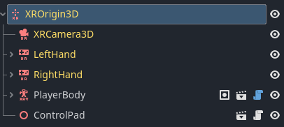
Figure 9 - Collapsed Node Tree for XROrigin3D
The core system, and the first that needed to be looked at, is the interaction system. In the figure above, the basic structure of the VR interaction system can be seen. XROrigin3D node contains the XRCamera3D, and the LeftHand and RightHand components. What isn’t shown here though, is that the LeftHand and RightHand contain their own child components as well, which I will discuss next. After the hand components is the PlayerBody. This node defines the collisions and behaviour for the user’s digital body, and prevents them from falling through the floors.
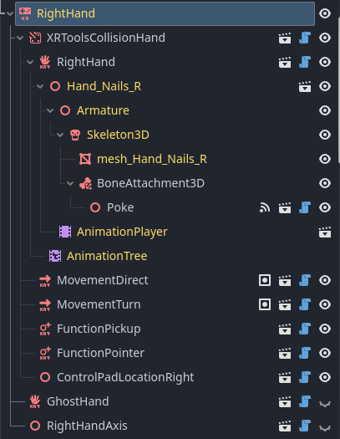
Figure 10 - Expanded Node Tree of RightHand
Shown here is the full listing of the child components of the RightHand. There’s the CollisionHand, which defines how the hand collides with other physical objects. This contains the 3D model and animations that actually make the hand look like a hand.
It also contains components that control user movement and turning, as well as components for picking up items, which is an XRToolsFunctionPickup node, and a menu pointer, which is an XRToolsFunctionPointer containing a RayCast, as previously discussed.
These can interact with other elements in the scene with the appropriate matching components, such as the XRToolsPickable.
The code for these elements is largely implemented by the XRTools library that they are included with, and will require only minor changes from myself to fit my needs. The next section is the one where more of my own code is required.

6.2.2 Screen System
The most basic unit of code from the screen system is the code that grabs the contents of the user’s computer screen, or from one of the simulated screens, and displays it on a 2D mesh plane. Essentially, each frame of the system, the script will capture the user’s screen contents, convert it to a 2D texture, and apply it to the material of a 3D mesh plane.
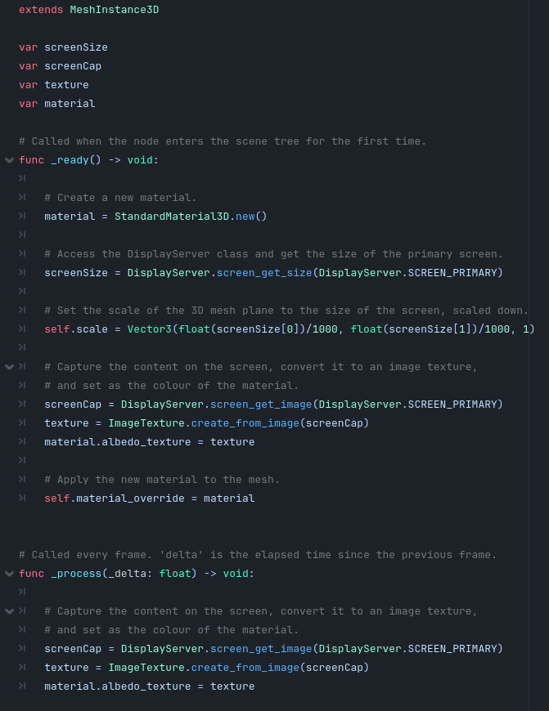
Figure 11 - Code Snippet Showing Screen Capturing Functionality
This figure shows the code representing the screen capture and streaming into the VR scene in its most basic form. The comments in the code do some amount to explain it, but because this is the first Godot code snippet in this report, I’ll explain how some of it works here. A script in Godot has two default functions. The first is the ready function, which acts as a setup function. This runs before the scene starts, and can be used to initialize variables and start processes.
The next default function is the process function. The process function runs every frame of the system. With a target frame rate of around 60 frames per second, this function should be running 60 times every second.
In the ready function, the system creates a new material. It then gets the size of the target screen, in this case the primary screen. The script scales the 3D mesh plane to the size of the screen. The size is scaled down by a lot because size in Godot is measured in meters. Using the base size, you might end up with a screen kilometres across. The screen size is instead divided by 1000, so that if your real screen was 1920x1080, the virtual one comes out to around 2 meters wide and 1 meter tall. This is still quite large, but the scale can be further adjusted later. Next, the script grabs the contents of the target screen, converting it into a 2D texture, and applying it as the “albedo”, or colour, of the material created before. It then applies this material to the 3D mesh plane.
The process function continues this. Each frame, the function will continue to grab the contents of the user’s screen, and refresh the virtual screen. The virtual screen will likely lag very slightly behind the content of the real screen, but it shouldn’t be too noticeable. While initially testing the script to ensure it actually works, I got a result like this:

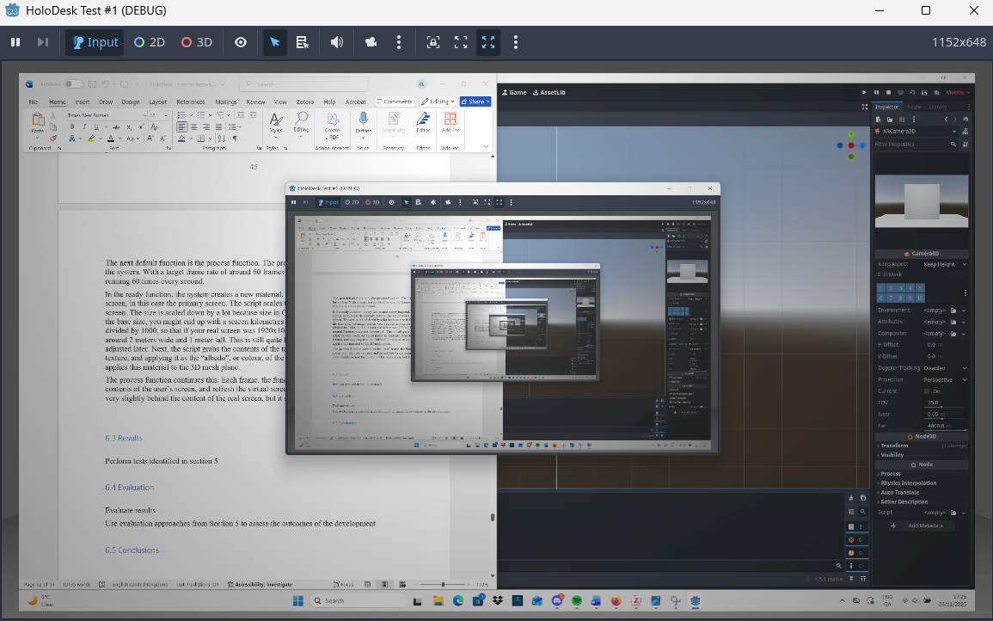
Figure 12 - Application Running with Screen Capture
As the figure shows, the screen contents are being captured and displayed on the virtual screen. Because the program itself is open on the screen, it creates a sort of infinite loop where it captures itself. It has also captured this report, which I left open when I took the screenshot.
The virtual screen object will be saved as its own scene, so that it can be instantiated later on from different Godot scripts, like the screen manager. The following figure shows the setup in the ready function of the screen manager, and how it will create its first screen. The system is being developed under the assumption that the user will have at least one real physical screen as their primary, which will have a virtual screen instantiated for it at runtime.
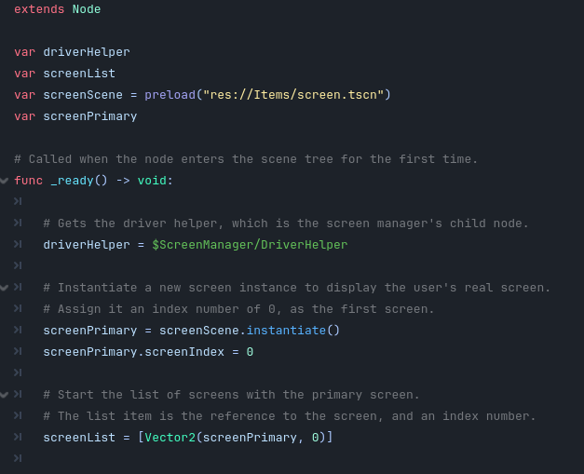
Figure 13 - Code Snippet Showing the Screen Manager Creating an Initial Screen
The figure shows that the script preloads the saved scene containing the virtual screen component. In the ready function, it gets the node for the driver helper, which it will need later on to communicate with the driver. It then instantiates the preloaded scene, and assigns the new instance an index number of zero. Lastly, it starts the list of screens with the new primary screen that was just created. It passes the list a 2D vector, the closest thing GDScript has to a tuple, containing the screen reference and an index number of 0.
The next most important part of the system for the prototype is the interactive shortcut system. The shortcut system, like the interaction system, also has a lot of the more complex code handled by the XRTools library. However, the shortcut objects are still quite complicated to set up, so it’s useful to have the demo versions from the example project as a reference point. The following figure shows the node structure of an example shortcut element.
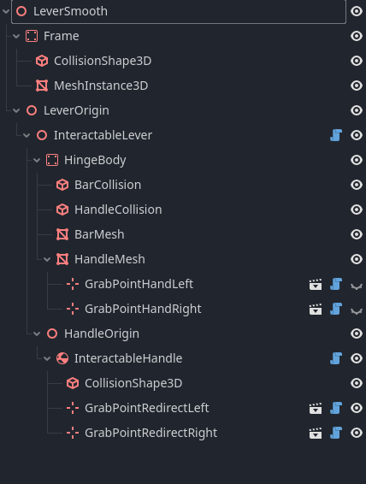
Figure 14 - Node Tree Showing Interactive Element
This is the structure for a lever with smooth movement. The Frame component is the fixed point the lever is attached to, like the baseplate. The LeverOrigin is the part that actually moves. Within this is the InteractableLever, which is an XRToolsInteractableHinge component. This defines how the hinge moves, as well as the collision for the lever part, and also defines where the user’s hand should go when they try to grab it. The HandleOrigin is the end of the lever, the handle, and XRToolsGrabPointRedirect nodes which will direct the hand trying to grab it to the appropriate grab point.

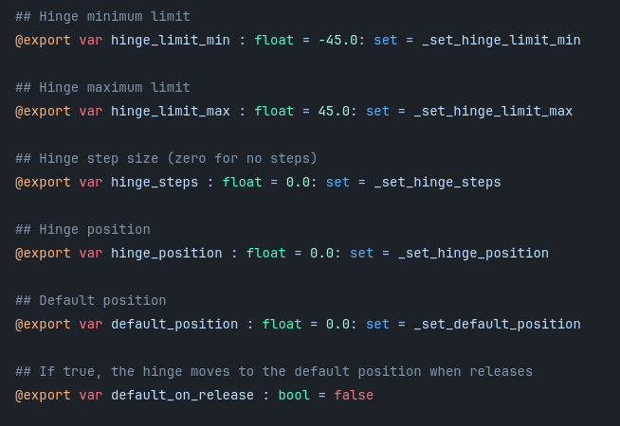
Figure 15 - Code Snippet Showing Script on Interactive Element

The example interactable component comes with a script attached. This part of the script defines the key variables for the hinge’s movement. The key part of triggering the command on the interactable shortcut is defining a threshold for “activation”. Once the hinge position variable meets the threshold, a signal will be sent to the command handler, to activate the relevant command.

6.3 Results
When it comes to testing, not much can be done with the prototype in its current state. There is just enough for basic functionality that is already done in order to do a demonstration, and that code that is already implemented has passed the test cases that apply. So far, these include minor or basic unit and integration tests. No user testing has occurred, as the program is still in the early stages of development. More testing will be carried out as development continues, and as more test cases become relevant.

6.4 Evaluation
The same applies to evaluation as testing. What parts of evaluation that do apply to the project in its current state have been good, but not all of the discussed evaluation criteria or methodologies do apply yet. This is actually more detrimental for evaluation than for testing, as the evaluation mostly involves how the system feels to use, and whether users are satisfied with it, which are factors that have mostly been ignored in favour of a baseline functionality for the prototype.

6.5 Conclusions
With this chapter complete, development of the prototype is well underway, with some of the key points and considerations discussed here. To list all of the scripts, components, and considerations exhaustively would be impractical, but I believe the code snippets and screengrabs shown here can give a good idea of what development is like for the prototype so far.

7. Issues and Future Work

7.1 Introduction
This section will lay out how the project will progress going into the future, what further development is planned, and what the schedule is going forwards. It will also discuss what the issues and risks are, both for the work that has already happened, and the work that has yet to come. Additionally, it will feature a Gantt chart planning out the rest of the project from the time of writing to March 2026.

7.2 Issues and Risks
Despite the relatively short time frame for which work on this project has been underway so far, I have encountered a number of risks and issues that bear discussion, as well as having identified a number of key risks that could cause problems down the line.
Firstly, on the hardware side, my VR headset won’t connect to my laptop. The idea is that this project is run on the laptop (which is necessary, because it needs to communicate with a system driver), and is displayed on and interacted with via the VR gear. However, the software to connect the headset isn’t working properly. I’ve tried every possible fix, including graphics driver updates, changes to process execution policies, and fiddling with antivirus settings. In the end, my only possible course of action was to find another computer to work on. Currently, development is underway on an old desktop PC, which is suboptimal, as it doesn’t quite meet the specifications required to run a VR app smoothly.
Next on the list is the driver. Working with, and sending messages to, a system driver like I need to do is highly complicated, and isn’t something that I’ve done before. Currently, during work on the prototype, the most I’ve managed is running some of the example PowerShell scripts the driver came packaged with in order to change some of the settings. While I am fairly confident that I will get the driver working as intended eventually, I do acknowledge that there is a serious risk that it may take me a long time, and a lot of work.
Finally, I believe performance will also be an issue. I have stated before that I aim to try to match the alternative solutions in terms of features and quality, but the fact of the matter is that the more virtual screens exist in the scene at once, the greater the impact on performance will be. It may play out that having 5 screens, as I would need to in order to match the alternative solutions, could have simply too much of a negative effect on the performance, and I may need to cap the number at 3 or 4.

7.3 Plans and Future Work
In this section, I’ll address how I plan to move forwards and address some of the key risks brought up previously. First, I’ll continue to build on the prototype to develop the full system. The customization options will be added, allowing the user to choose between multiple choices for types of interactive shortcuts, commands for shortcuts, and surrounding environments. I will also continue to work on accessibility options and settings, adding support to differentiate controls for left or right-handed people, as well as settings to help mediate VR sickness such as a movement vignette and teleporting locomotion.
To address my risks, first off, I plan to look into getting a new laptop. I know it’s an extreme step, and a lot of money to spend, but I need to be able to work and continue development portably, and an old desktop PC just won’t live up to the task.
Next, to address the driver issue, I plan to do a lot of research in the coming weeks and months into how exactly system drivers, and more specifically the display driver I’ll be using, work. I’ll analyse the code from start to finish, and take notes on it all, which will hopefully boost my understanding of it. Additionally, it seems like PowerShell scripts are a preferred way of communicating with the driver based off of its GitHub page[11], so I’ll research how to write those better as well.
Additionally, for the performance risk, I plan to do lots of research into Godot optimization in general, but also rendering optimization techniques, and how displays like the virtual screens can be optimized without sacrificing quality.

Lastly, I have to consider testing and evaluation going forwards. As more of the test cases described in Chapter 5 become relevant, they will be carried out in order to ensure full system functionality. Additionally, certain elements of the testing process will be planned out on my Gantt chart, which will be shown below.

7.3.1 Project Plan with GANTT Chart

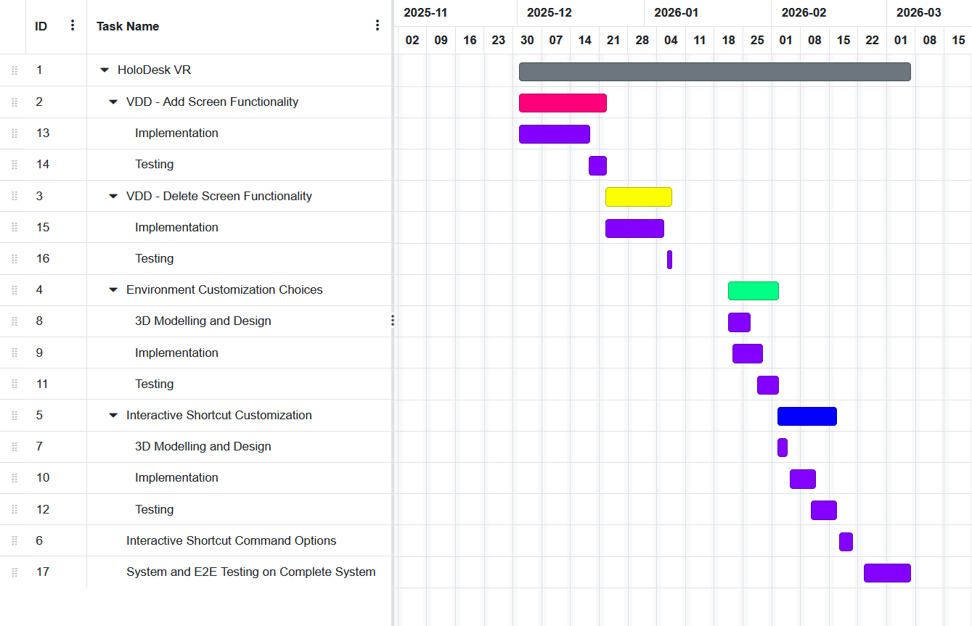
Figure 16 - Gantt Chart Representing Project Plan Going Forwards
This Gantt chart represents my plans for the project moving forward. The prototype incorporates core functionality, so my plans going forward build off of that. The first step is to ensure that communication with the virtual display driver in order to create and delete virtual screens, followed by testing for that. This continues for environment and shortcut customization, with testing for those too, as well as integration for more and improved shortcut command options. Lastly, when all of the key components are in place, I’ll be able to perform end-to-end tests on the completed system.

References
[1] “PDF.” Accessed: Nov. 18, 2025. [Online]. Available: https://repository.mdx.ac.uk/download/cca1399a3b0e5b96010ce614c60252d636800018a9ea0ce55abd57419eac2780/709639/Priporas%20et%20al%202024-Acepted%20manuscriptIJIM%20final.pdf
[2] “Avoid Your Bedroom as Your Remote Workspace | Sleep Foundation.” Accessed: Oct. 22, 2025. [Online]. Available: https://www.sleepfoundation.org/sleep-hygiene/remote-work-and-sleep
[3] lorihollasch, “Indirect Display Driver Model Overview - Windows drivers.” Accessed: Nov. 19, 2025. [Online]. Available: https://learn.microsoft.com/en-us/windows-hardware/drivers/display/indirect-display-driver-model-overview
[4] “Multiple monitors boost productivity by up to 35.5%,” Éire Graphic Design. Accessed: Oct. 10, 2025. [Online]. Available: https://www.graphicdesigneire.ie/graphic-design-blog/multiple-monitors-boost-productivity-by-up-to-35
[5] D. S. Tan, J. K. Stefanucci, D. R. Proffitt, and R. Pausch, “The Infocockpit: providing location and place to aid human memory,” in Proceedings of the 2001 workshop on Perceptive user interfaces, Orlando Florida USA: ACM, Nov. 2001, pp. 1–4. doi: 10.1145/971478.971526.
[6] E. Chang, H. T. Kim, and B. Yoo, “Virtual Reality Sickness: A Review of Causes and Measurements,” International Journal of Human–Computer Interaction, vol. 36, no. 17, pp. 1658–1682, Oct. 2020, doi: 10.1080/10447318.2020.1778351.
[7] M. Ponticorvo, L. S. Sica, A. Rega, and O. Miglino, “On the Edge Between Digital and Physical: Materials to Enhance Creativity in Children. An Application to Atypical Development,” Front Psychol, vol. 11, p. 755, May 2020, doi: 10.3389/fpsyg.2020.00755.
[8] S. Price and Y. Rogers, “Let’s get physical: The learning benefits of interacting in digitally augmented physical spaces,” Computers & Education, vol. 43, no. 1, pp. 137–151, Aug. 2004, doi: 10.1016/j.compedu.2003.12.009.
[9] Atopia, “Who’s Really Using VR these days? Six Data-Driven insights into today’s VR User Demographic,” Medium. Accessed: Nov. 19, 2025. [Online]. Available: https://medium.com/@annabell_37704/whos-really-using-vr-these-days-six-data-driven-insights-into-today-s-vr-user-demographic-422372a75c8c
[10] H.-P. Balzerkiewitz and C. Stechert, “How to Assess the Usability of Virtual Reality (VR) systems for Implementation in Product Development Processes,” Procedia CIRP, vol. 128, pp. 460–465, Jan. 2024, doi: 10.1016/j.procir.2024.03.027.
[11] VirtualDrivers/Virtual-Display-Driver. (Nov. 23, 2025). C++. VirtualDrivers. Accessed: Nov. 23, 2025. [Online]. Available: https://github.com/VirtualDrivers/Virtual-Display-Driver

Appendix A: System Model and Analysis

My primary requirements gathering method, besides what was discussed in Chapter 3, was a Microsoft Forms survey, which can be found here.
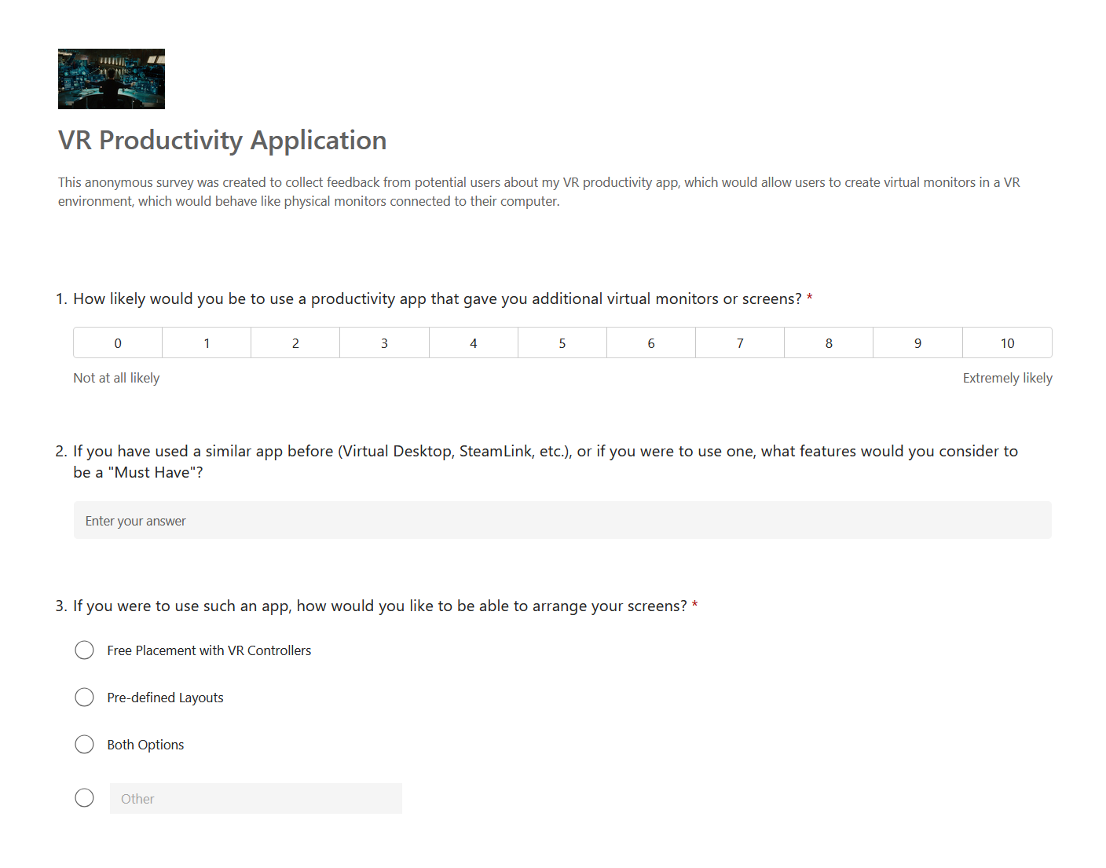
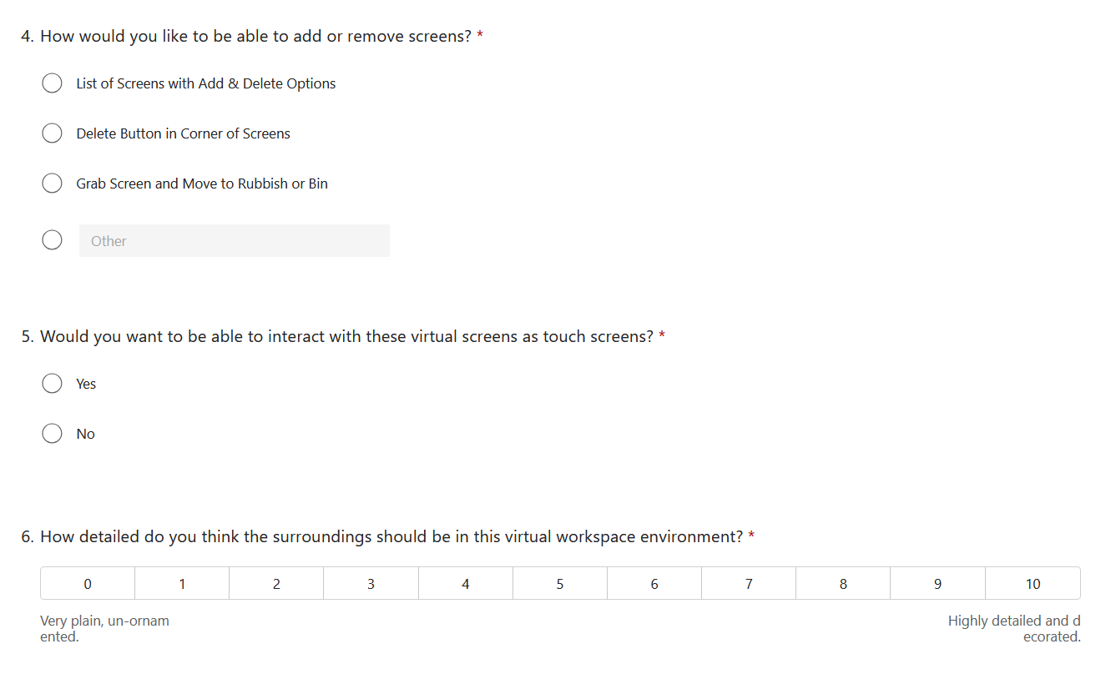

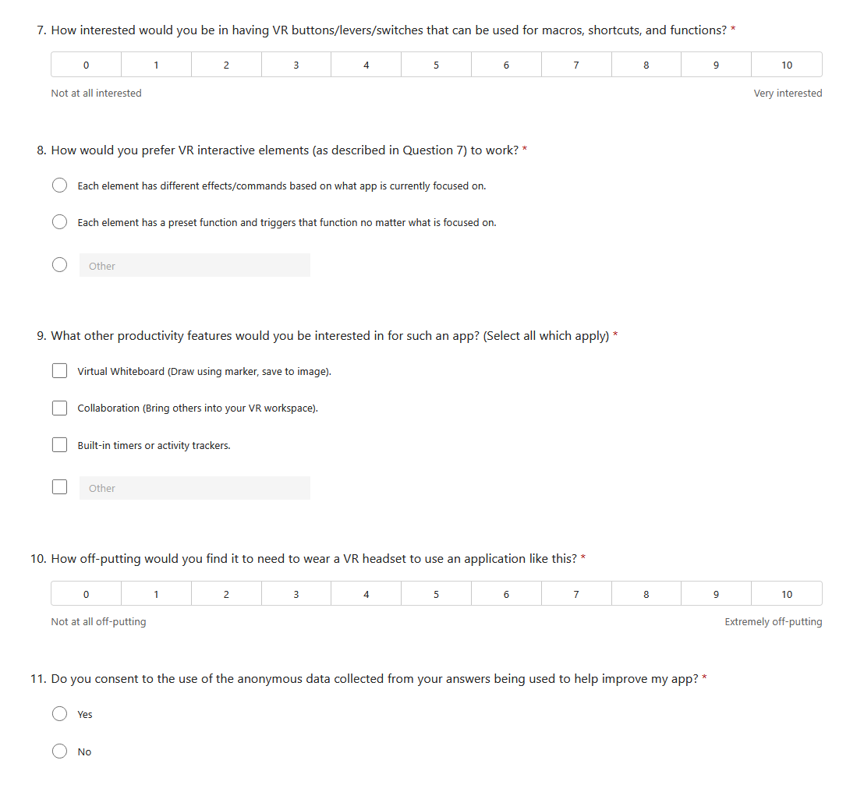

Appendix B: Design

As discussed in Chapter 4, the system was designed using a component-based design methodology. Included here are the relevant diagrams used to help design the system.
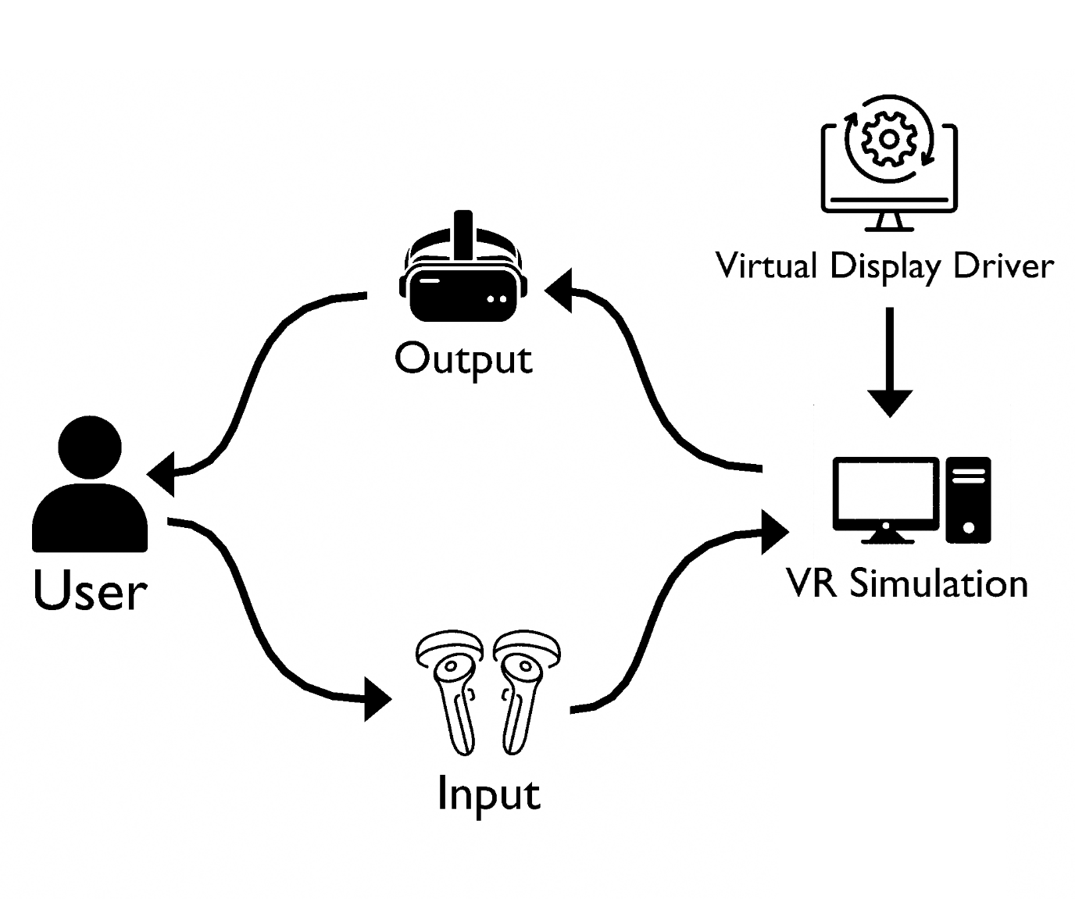

Appendix D: Additional Code Samples

Provide additional code samples
Organised by Logical Architect

